**CPS My Tomorrow APP**

**Admin, School Admin & Organization Documentation**

Table of Contents

1. Admin 4

Logging in: 4

Admin Dashboard: 4

Search: 4

Notifications: 5

Edit & Delete Newsfeeds (Posts) 5

Menu 7

Newsfeed 8

Newsfeed Approvals tab 8

Approve Comments tab 9

*To Approve or Reject or Delete multiple Comments at once:* 9

To create a Newsfeed: 10

Events: 12

To create an Event: 13

*To edit event’s details:* 14

*To delete event:* 15

Students: 16

Edit Student 17

Teachers: 18

How to make teacher as School Admin: 18

Remove School Admin Permission: 18

Edit Teacher: 18

Organizations: 19

Organization Approvals tab: 19

Approved Organizations tab: 21

Opportunities Approvals tab: 22

Approved Opportunities tab: 25

Rejected Opportunities tab: 26

Rejected Organizations tab: 27

Organization Opportunities: 27

Opportunities Approvals tab: 27

Approved Opportunities tab: 29

Rejected Opportunities tab: 30

Hall Pass 31

Published Hall Passes tab 31

Hall Pass Requests tab: 31

To creating a New Hall Pass: 32

Rewards: 33

Available Rewards tab: 33

*To edit reward’s details:* 33

Assign Points Tab 34

Assign Rewards for Action Tab: 35

Reports: 37

Schoology: 38

Assign Points for Students: 38

Power School: 38

Assign Points for Students: 39

Suggestions Box: 39

Suggestion Feed tab: 39

*To Post a comment to a suggestion:* 40

*To delete suggestion:* 41

Approve Suggestion tab: 41

Approve Comments tab: 41

*To delete suggestion:* 42

Settings: 42

Help 43

2. Organization 44

Logging in: 44

Organizer Dashboard: 45

*To edit organization:* 45

Opportunities: 45

Opportunities Approvals tab: 45

To create Opportunity: 46

*To edit opportunity:* 46

*To delete opportunity:* 47

Approved Opportunities tab: 48

*To delete opportunity:* 48

Interested Students tab: 48

Selected Students tab: 50

Rejected Students tab: 51

Rejected Opportunities tab: 52

*To delete opportunity:* 52

3. School Admin 53

Logging in: 53

# 1. Admin

## Logging in:

To log in to the Cincinnati Public Schools website as an administrator, the following are the steps to be performed:

* Enter a valid username and password in the respective text boxes and click the **Login** button.
* You will be redirected to the admin dashboard screen.

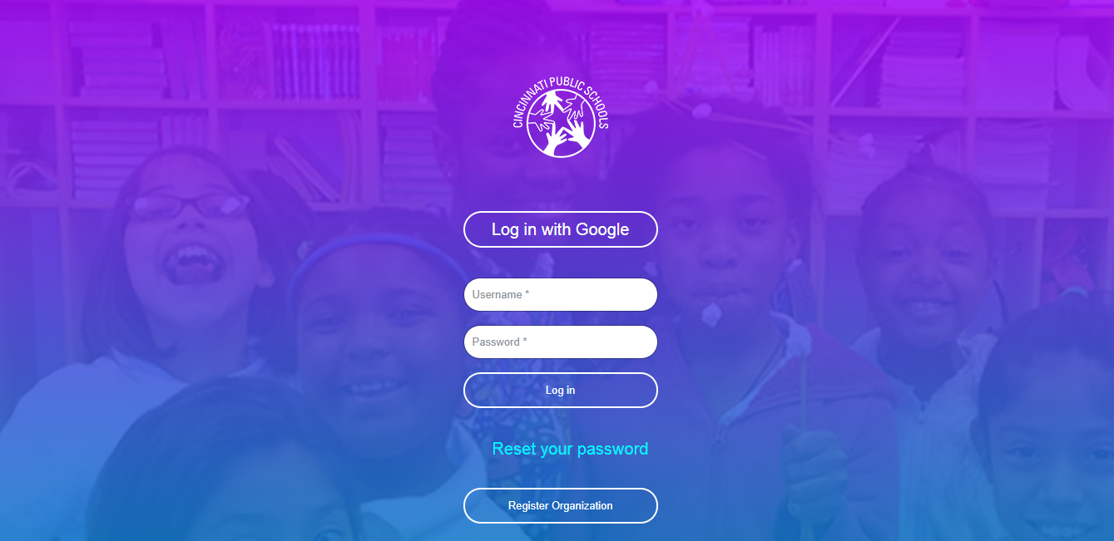

## Admin Dashboard:

When you log in as an administrator, you can view the newsfeeds posted by other admin users, students and teachers and the various events posted by the admin users on your dashboard screen. You can perform multiple activities including like posts, comment on posts, search for posts, delete posts, check notifications. You can also view the top 5 students list on the right of the screen.

### Search:

The Admin users can search for information on the dashboard page based on certain key words. There is a **Search** text box available at the top of the feeds. They can type keyword(s) and the search result will be displayed below the **Search** text box based on the keyword typed.

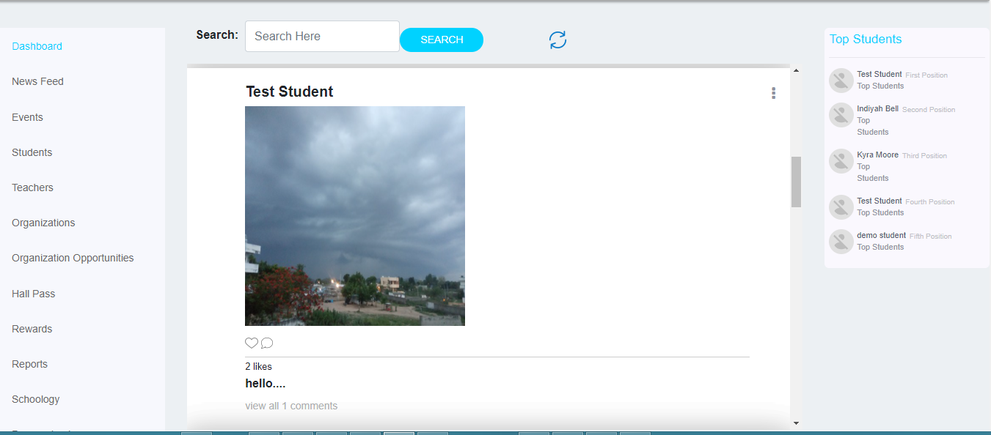

## Notifications:

The Notifications screen displays all the updates related to the students, teachers and organizers. Click the bell icon displayed at the top of the Dashboard screen to access the Notifications screen. On this screen, you can view notifications including new posts, hall pass requests, suggestions, likes or comments on the posts created by students, teachers, organizations and the opportunities by the organizer. You can click on any of the notifications to access the details of that particular notification. You can view all notifications by clicking the **View All** link.



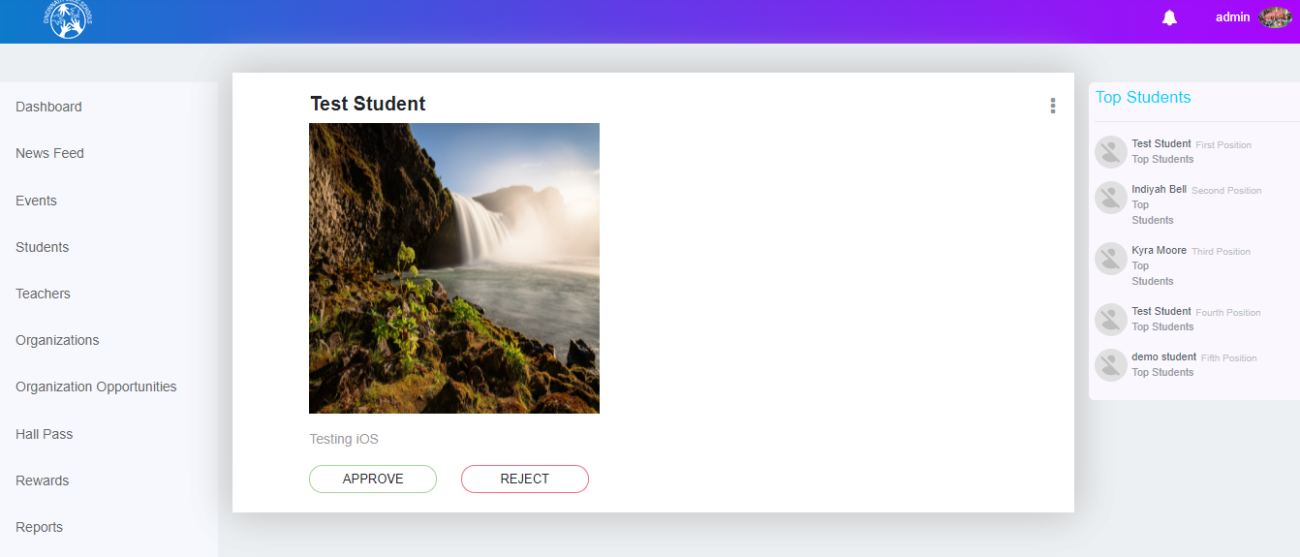

## Edit & Delete Newsfeeds (Posts)

The admin users can edit their own newsfeeds and delete all newsfeeds or comments on a newsfeed.

**To edit a newsfeed:**

* Click on the newsfeed you want to edit.
* On the newsfeed details window, click the icon displayed at the top right corner of the newsfeed
* Click the **Edit Newsfeed** button.

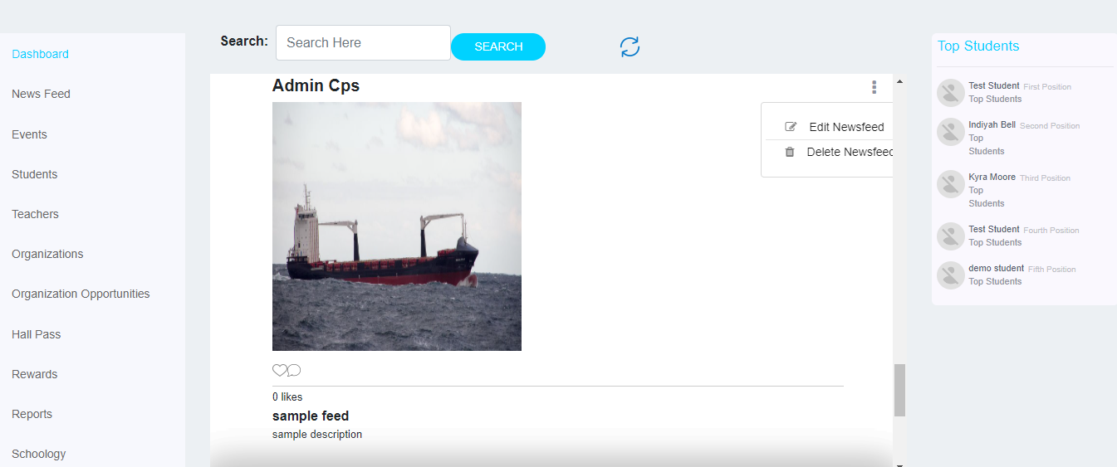

* When you click on the ‘Edit Newsfeed’ button, the newsfeed form will pop out with the newsfeed details.

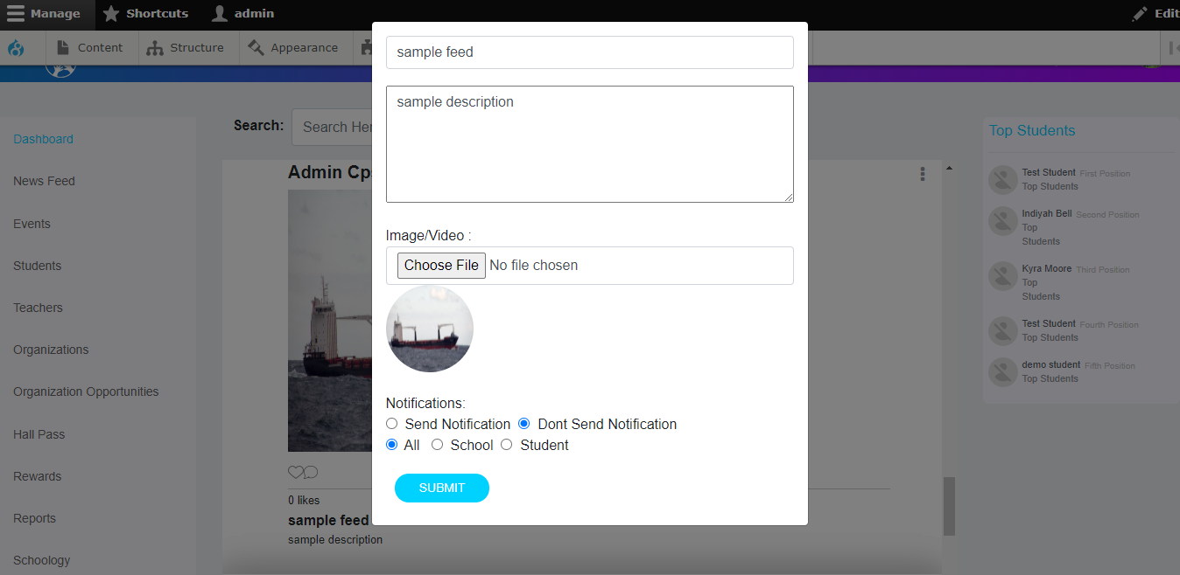

* If any changes are made, the submitted changes can be saved and displayed in the dashboard.

**Note:** The students and the schools associated with that newsfeed will receive a notification and a message from the administrator, informing them of the changes made to the newsfeed.

**To delete a newsfeed:**

* Click on the newsfeed you want to delete.
* On the newsfeed details window, click the  icon displayed at the top right corner of the newsfeed.
* Click the **Delete Newsfeed** button.



**Delete Newsfeed approved comments:**

The Admin users can view all the comments which have been made on a newsfeed and can delete individual or multiple comments, at once.

**To delete multiple comments at once:**

* Select the corresponding checkboxes for the comments placed next to the comments.
* Click **Delete** button below the comments list.

**Note:** The users whose comments have been deleted, will receive a notification from the administrator informing them about the status(deleted) of their comments.

**click on view all comments to see comments**

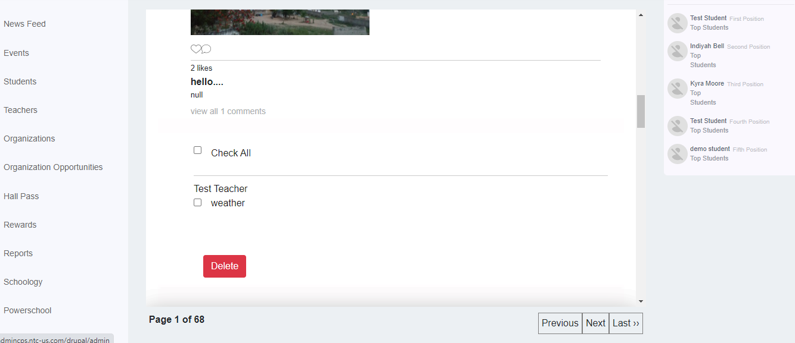

## Menu

There is a **Menu** displayed on the left side of the Dashboard screen. This menu displays all the screen and sections which an admin has access to. You can click the menu item you want to access and navigate to that screen.



## Newsfeed

The Admin users can view all the approved newsfeeds and comments posted by the students and teachers. They can also create and post newsfeeds. On the Newsfeed screen, there are two tabs; **Newsfeed Approvals** and **Approve Comments**.

### Newsfeed Approvals tab

The Admin users can view the newsfeeds posted by the students and teachers which are awaiting approval. On this screen, the admin can approve or reject a newsfeed. You can also search for newsfeeds and approve, reject or delete them.

#### To approve newsfeeds:

* On the Newsfeed Approvals tab, select the newsfeed to be approved.
* Click the **Approve** button at the bottom of the newsfeed.

#### To reject newsfeeds:

* On the Newsfeed Approvals tab, select the newsfeed to be rejected.
* Click the **Reject** button at the bottom of the newsfeed.

**Note:** The students and teachers associated with that newsfeed will receive a notification and a message from the administrator informing them of the approval or rejection of the newsfeed.

#### To delete newsfeeds:

* Click the icon displayed at the top right corner of the newsfeed.
* Click the **Delete Newsfeed** button.

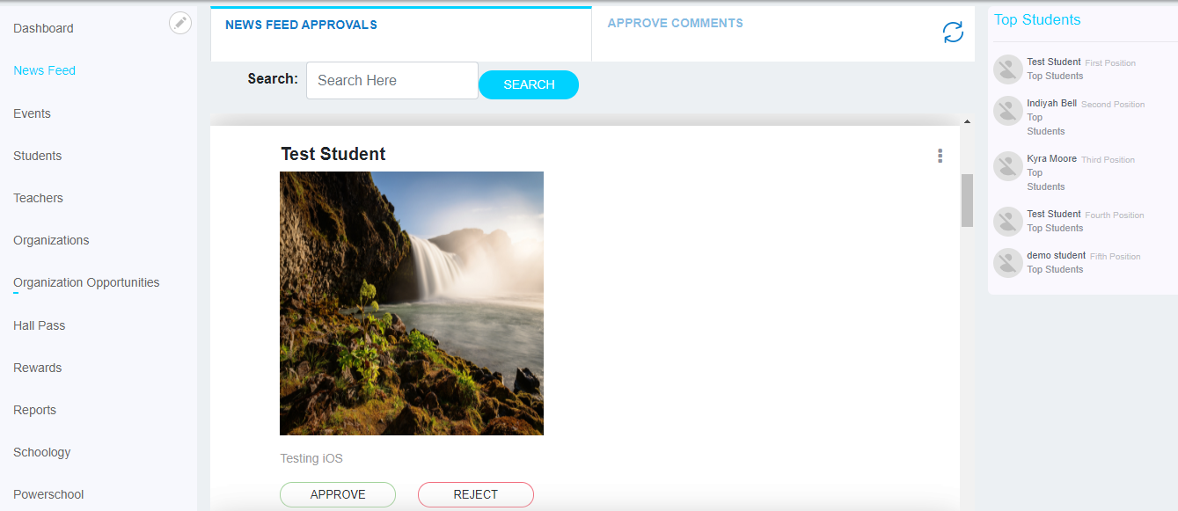

Click on ellipsis icon to delete Newsfeed

### Approve Comments tab

The Admin users can view all the comments which have been made on a newsfeed and approve or reject or delete individual or multiple comments at once.

### *To Approve or Reject or Delete multiple Comments at once:*

* Select the **Check All** checkbox to select all comments at once or select the corresponding checkboxes for the comments placed next to the comments.
* Click the **Approve** or **Reject** or **Delete** buttons below the comments list.

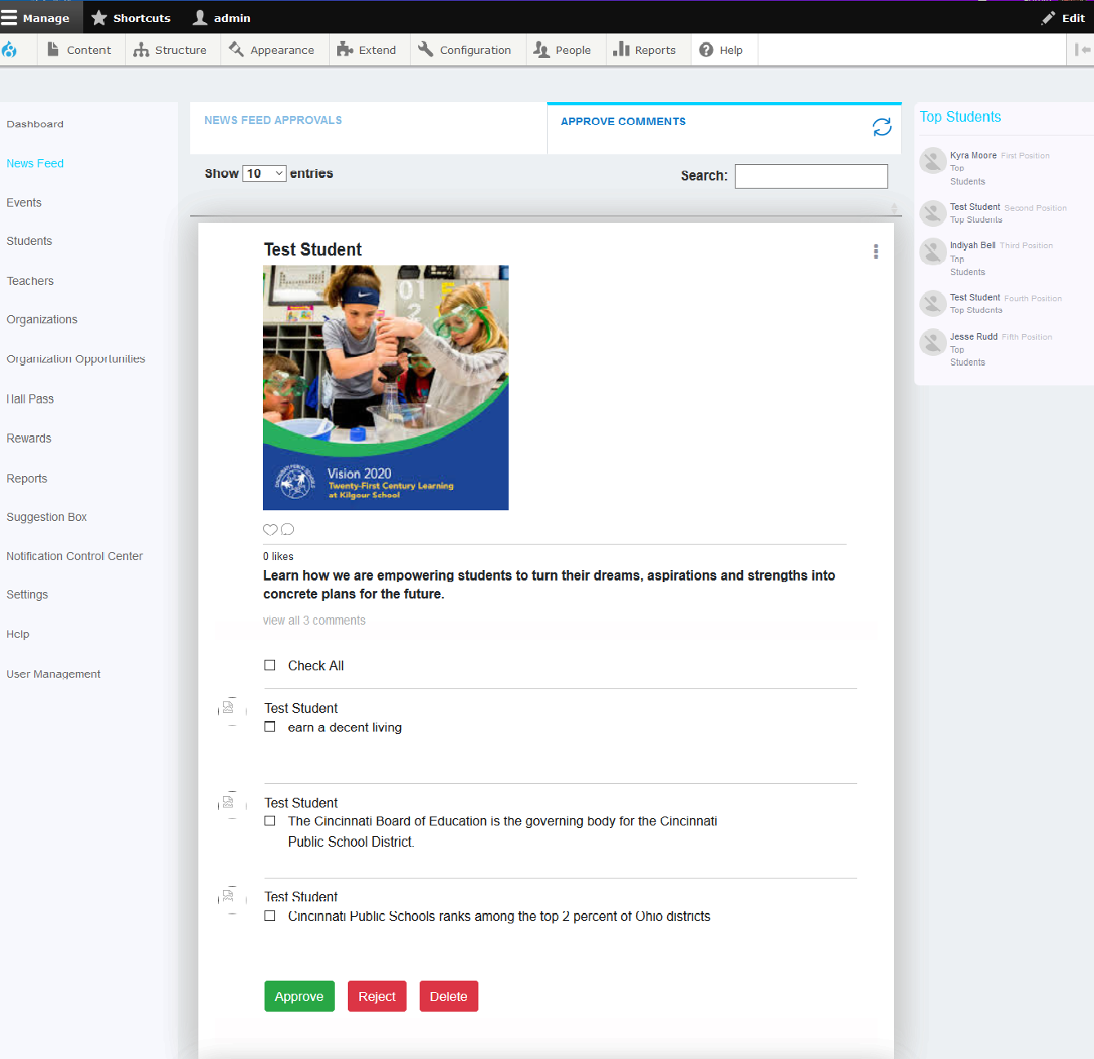

Click on ellipsis icon to delete Post With comments

**Note:** The users whose comments have been approved or rejected will receive a notification from the administrator informing them about the status of their comments.

Admin users can also publish a newsfeed.

### To create a Newsfeed:

* Click the **Create News Feed** button at the top right corner of the Newsfeed screen. The Create Newsfeed window will be displayed.

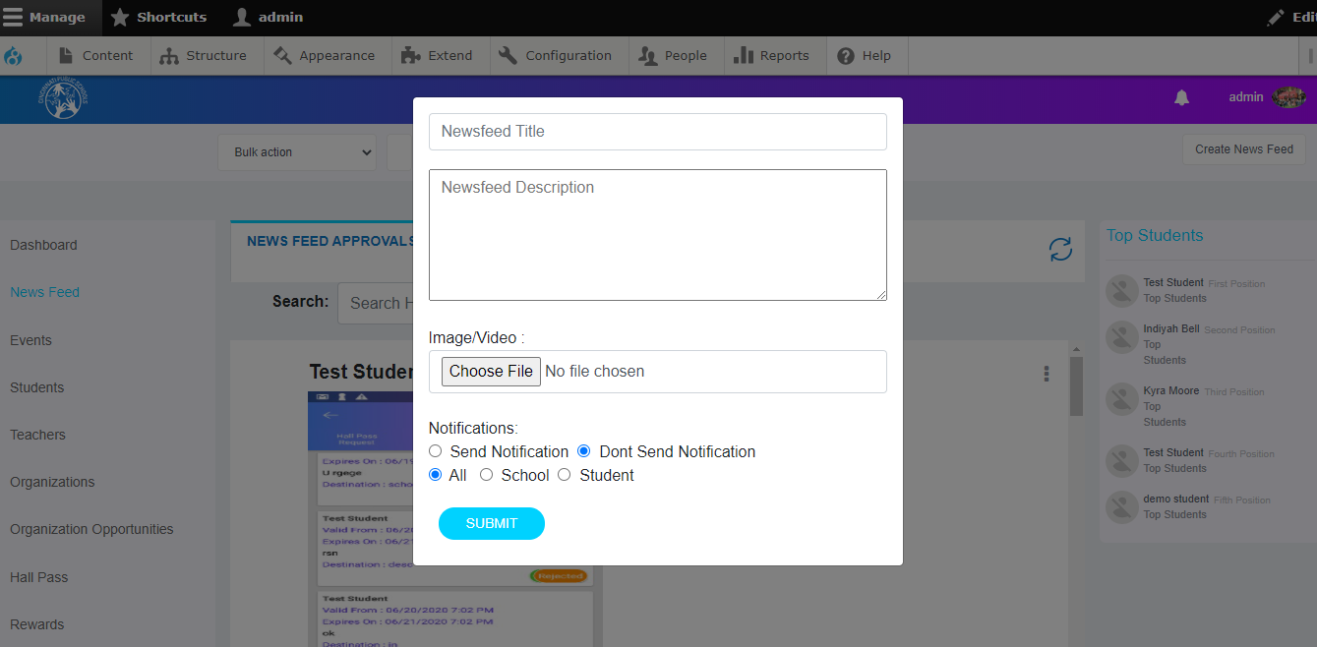

* Specify the title of the newsfeed and its description in the respective text boxes.
* Click the **Browse** button to upload an image or video as required.
* Select the **Send Notification** radio button if you want to send a notification about the newsfeed to all the students and teachers or select the **Don’t Send Notification** radio button if you do not want to send notifications to anyone.
* You can also choose to make the newsfeed visible to a set of schools or all schools.
* Select the **All** radio button if you want to make the newsfeed visible to all schools and all students
* Select the **School** radio button if you want to make the newsfeed visible to a particular school or a group of schools or set of students as per their grades.

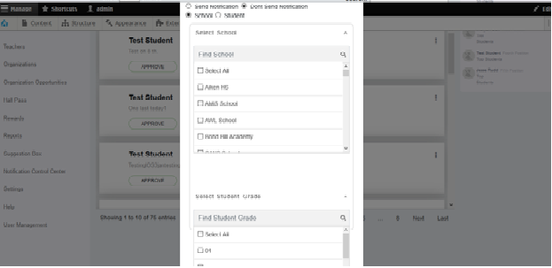

* Select the school or schools or set of students as per their grades you want to make the newsfeed visible.

**Note:** You can also search for a particular school or grade from the available list by typing in the name of that school or grade and clicking the search icon.

* You can also choose to make the newsfeed visible to student list uploaded. Select the **Student** radio button if you want to make the newsfeed visible to a student list uploaded.

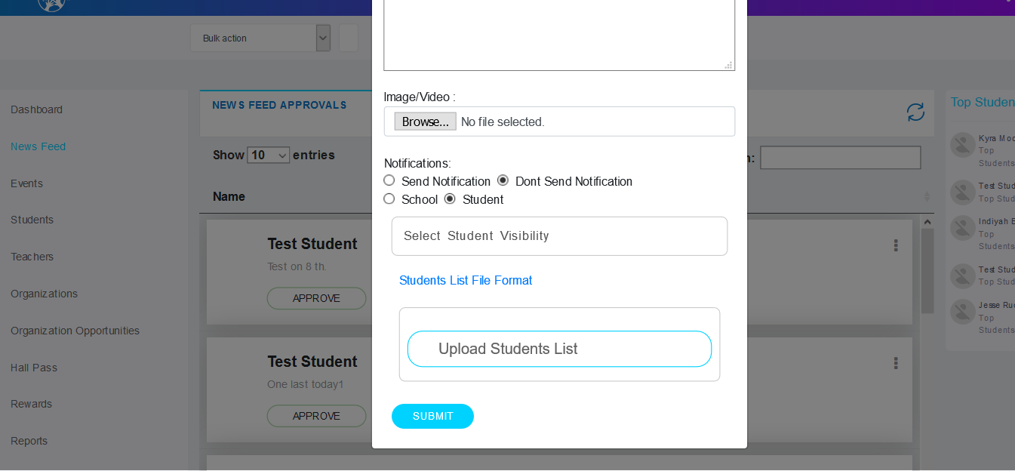

* When you click on **Students List File Format**, Sample Students List file will be downloaded to know which format file should be upload
* Select the **Upload Student List** radio button to make the newsfeed visible to a set of students irrespective of their grades. Click the **Upload Students List** button to upload your list.
* Click the **Submit** button to create the newsfeed.

**Note:** The students and the schools associated with that newsfeed will receive a notification and a message from the administrator informing them of the newsfeed creation.

## Events:

The admin users can view all events posted by the various admin users. They can also create and post events. On the events screen, the admin can filter the events by school and category or search for an event.

You can also edit the details of events.

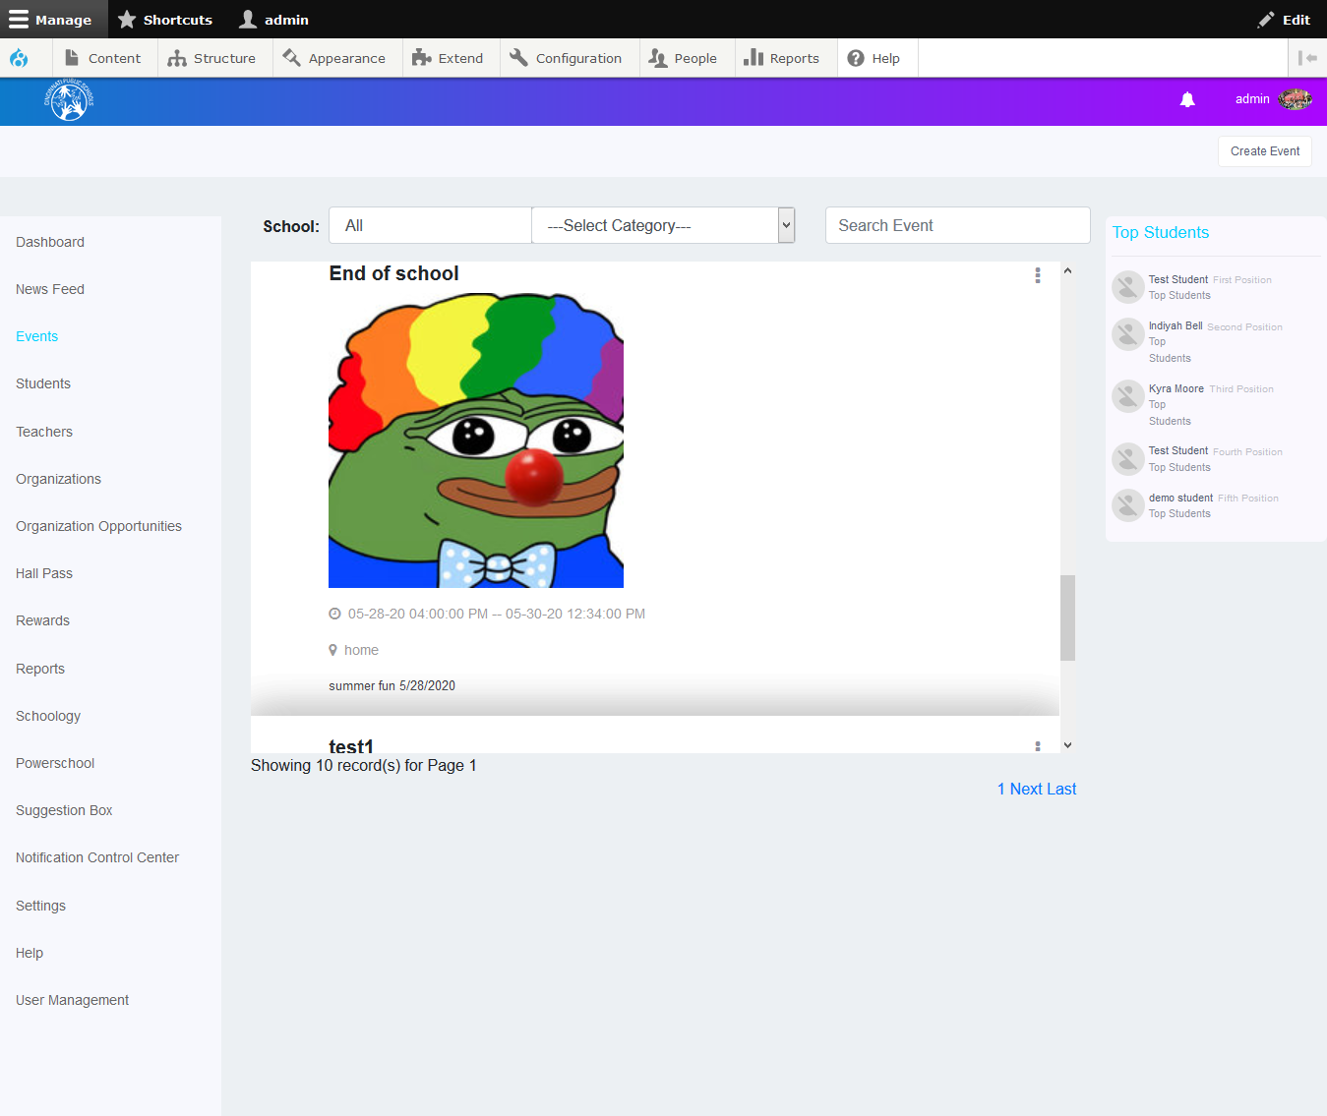

The admin users can also publish a newsfeed.

### To create an Event:

* Click the **Create Event** button at the top right corner of the events screen. The Create Event window is displayed.

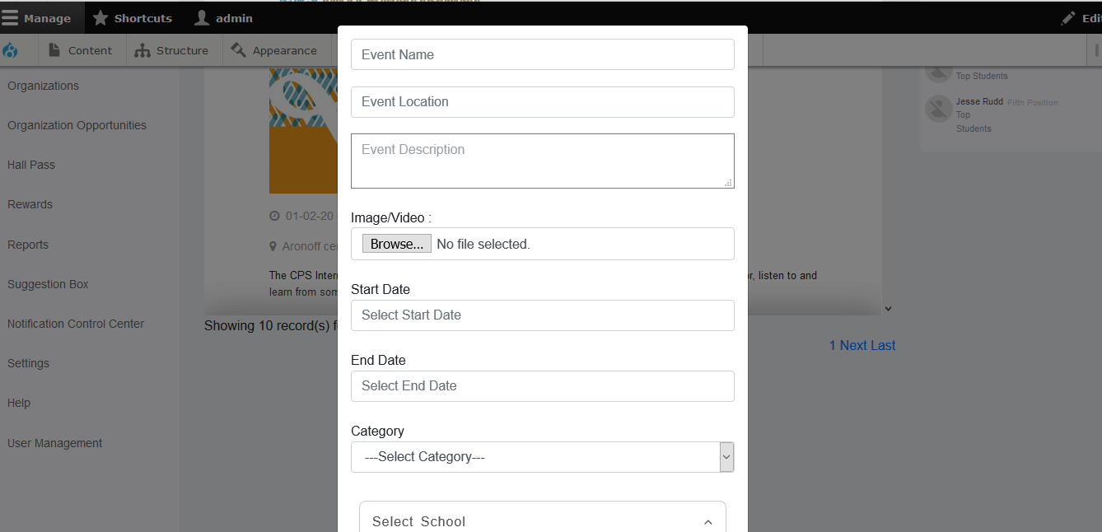

* Specify the name of the event and the location and its description in the respective text boxes.
* Click the **Browse** button to upload an image if needed.
* Select the Start date and End Date and category of the event.
* You can also choose to make the event visible to a set of schools. Select the **Schools and Grades,**  if you want to make an event visible to a particular school or a group of schools or set of students as per their grades.

## *To edit event’s details:*

* Click the ellipsis icon as shown in the screen below.
* Click the **Edit Event** button.

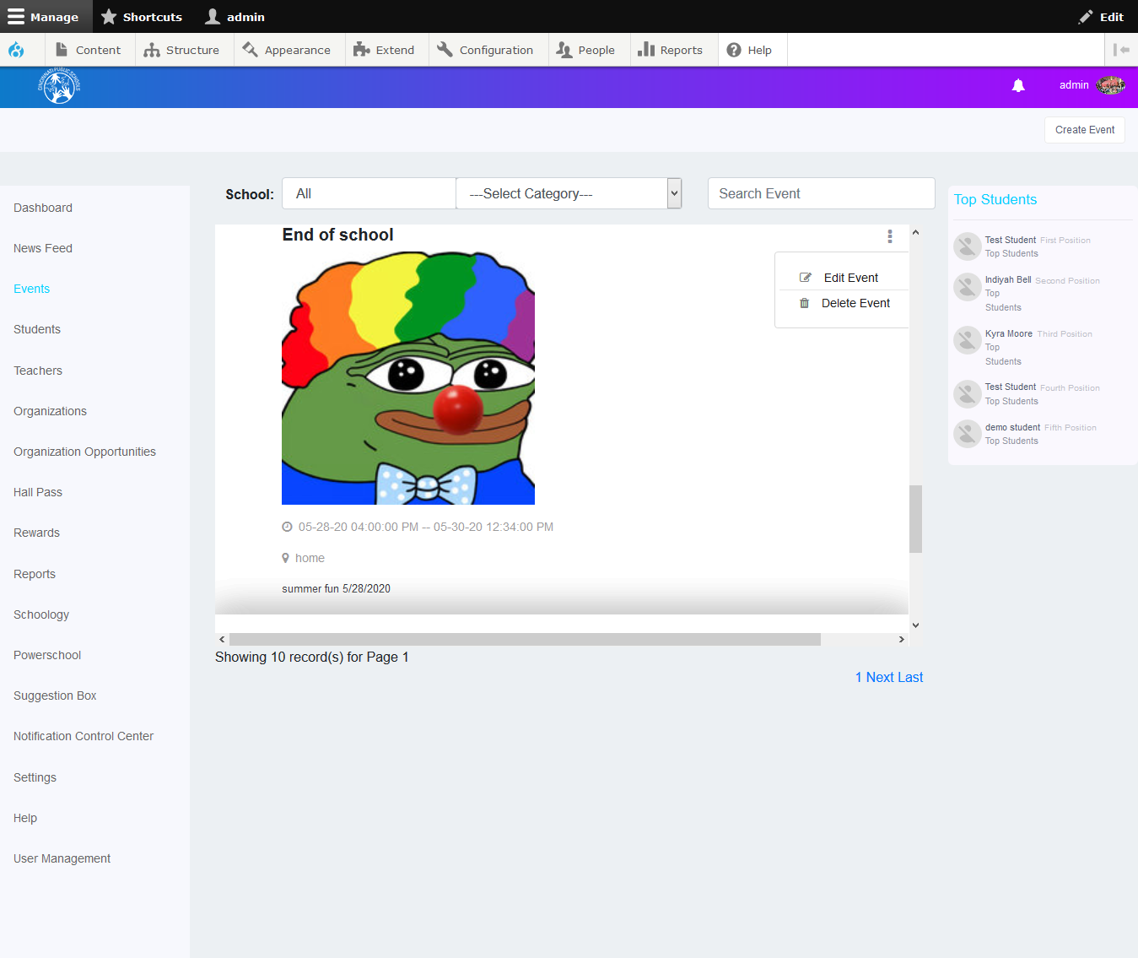

* The Edit Event window is displayed.

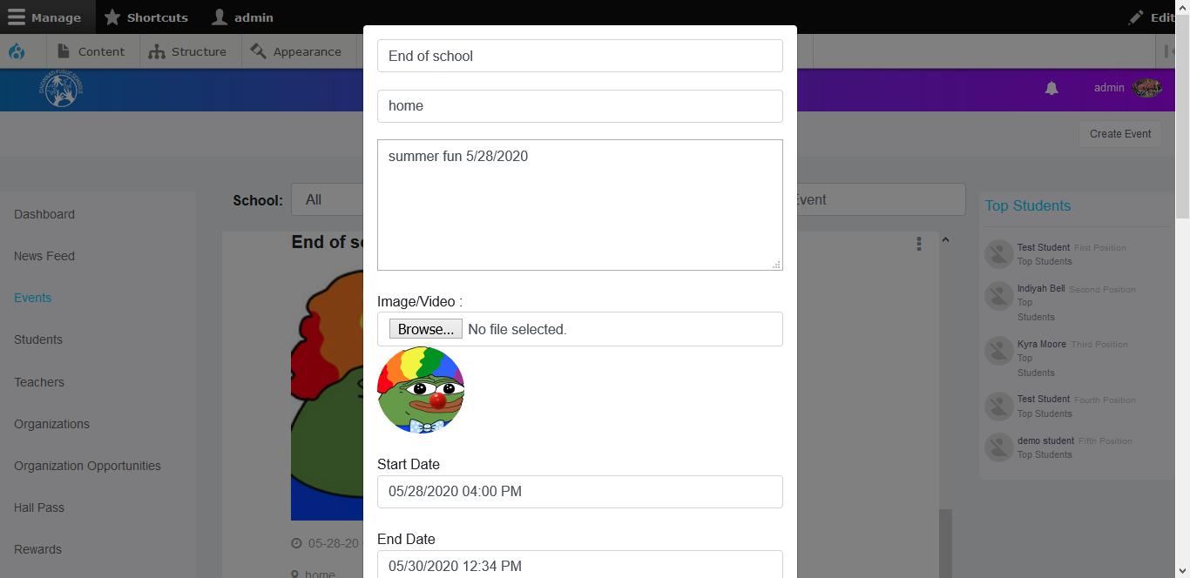

* In this window, you can edit the Event’s information.
* Click the **Submit** button to save your changes.

**Note:** The students and the schools associated with that event will receive a notification and a message from the administrator informing them of the creation or an edit to the event.

## *To delete event:*

* Click the ellipsis icon as shown in the screen below.
* Click the **Delete Event** button.

## 



## Students:

All the information of the students is displayed in this screen. You can filter the information by School, Student Name & Student ID.

You can also search for a particular student.

**To search for a student**:

* Type the student’s name in the **Search Student** text box
* Click the **Search** button. The results of the search for the student name is displayed.

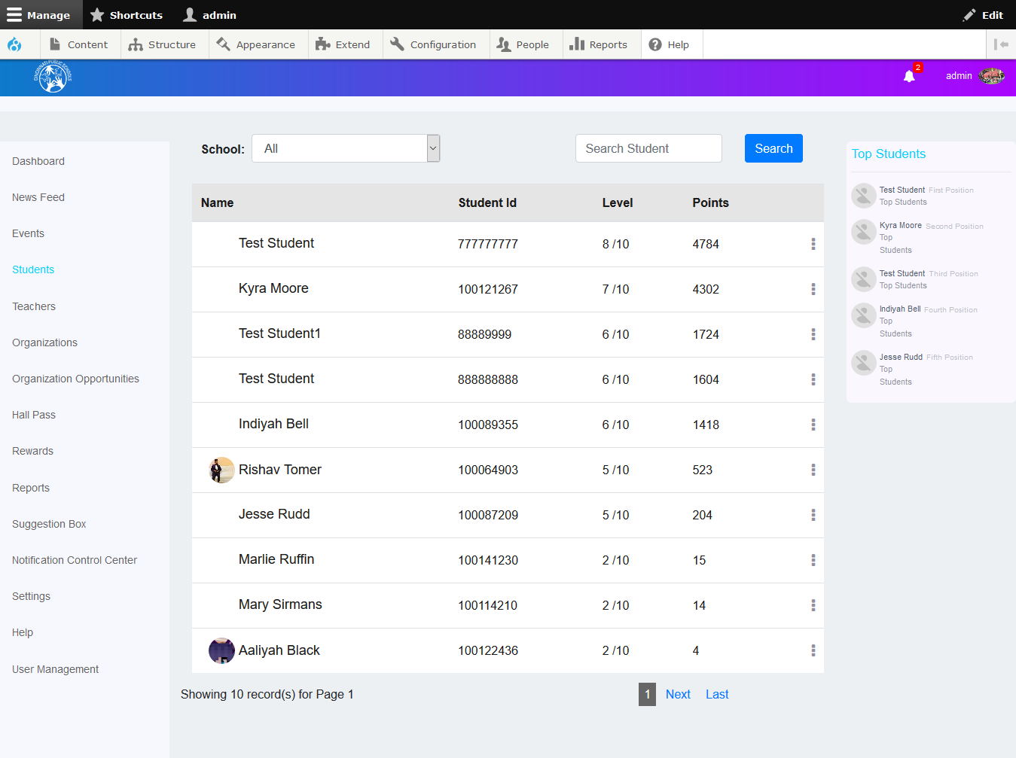

You can also edit the details of the students.

**To edit a student’s details:**

* Click the ellipsis icon as shown in the screen below.
* Click the **Edit Student** button.

### Edit Student

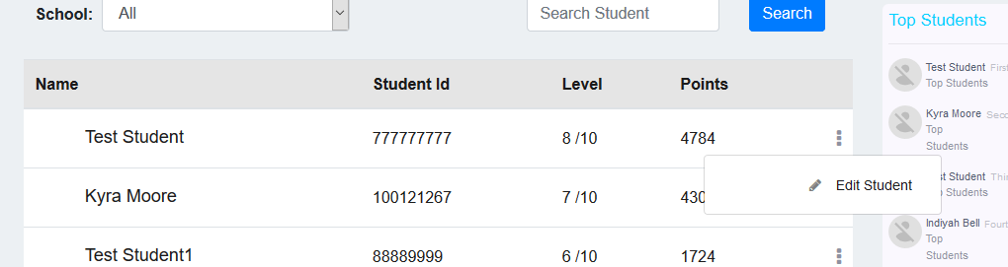

* The Edit Student window is displayed.

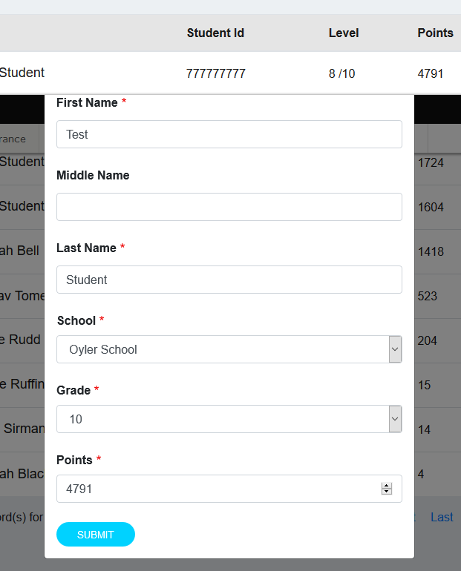

* In this window, you can edit the student’s information including first name, middle name, last name, school, grade and points.
* Click the **Submit** button to save your changes.

## Teachers:

All the information of all the teachers is displayed in this screen. You can filter the information by school.

You can also search for a particular teacher by name, title and email.

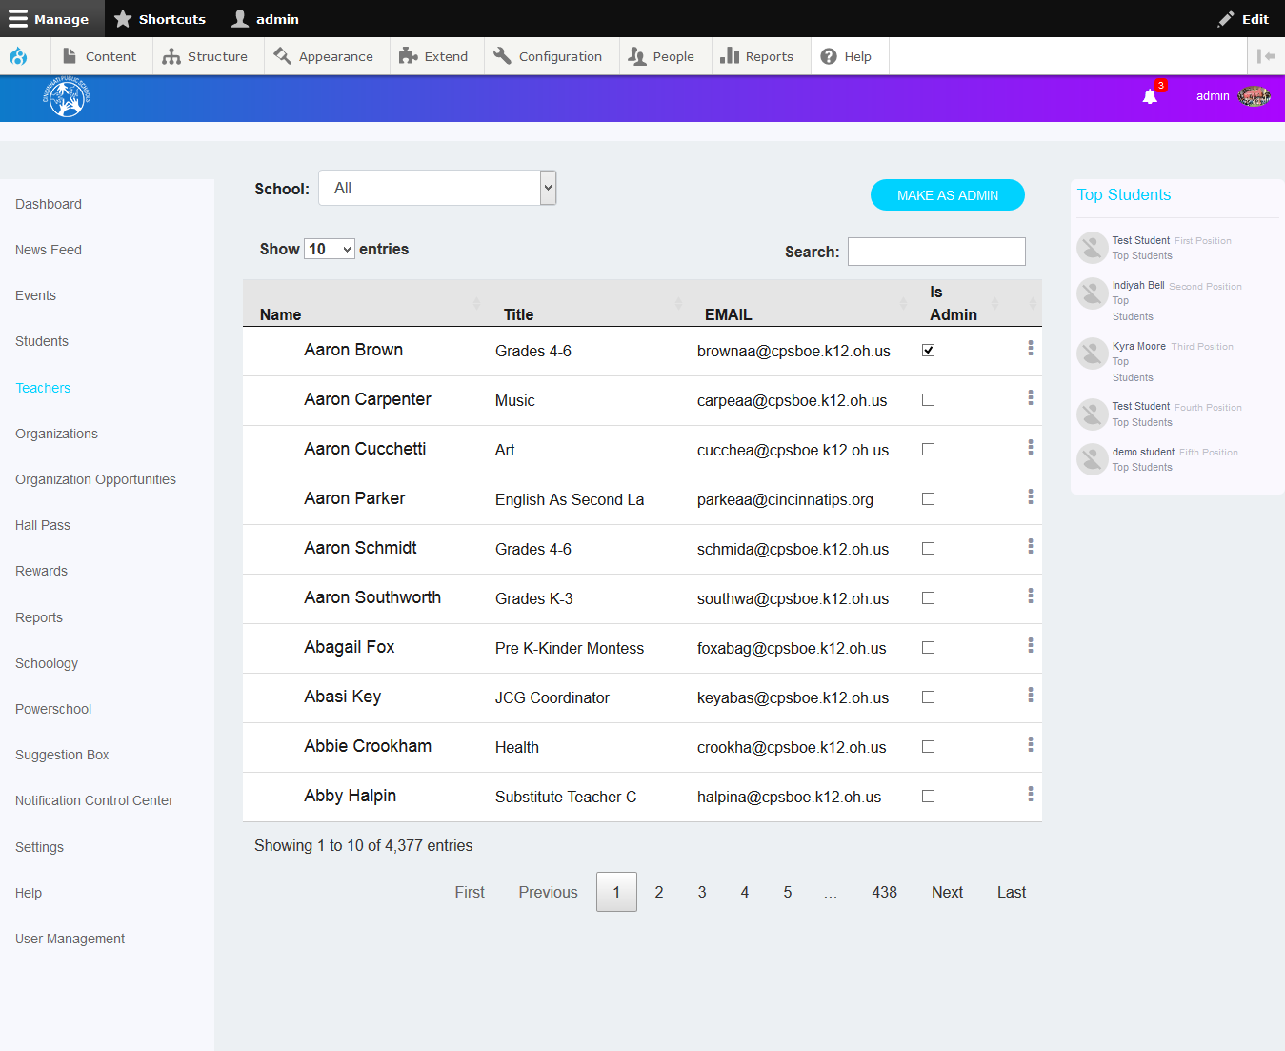

### How to make teacher as School Admin:

* Select the corresponding checkboxes of teachers to make as School Admin.
* Click **Make as Admin** button above the teachers list.

### Remove School Admin Permission:

* Simply uncheck the checkbox of teacher to remove the teacher as a school Admin.

**To edit a teacher’s details:**

* Click the ellipsis icon as shown in the following screen.
* Click the **Edit Teacher** button.

### Edit Teacher:

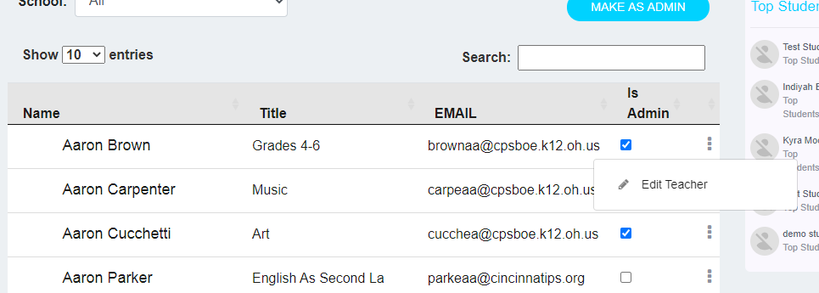

* The Edit Teacher window is displayed as follows.

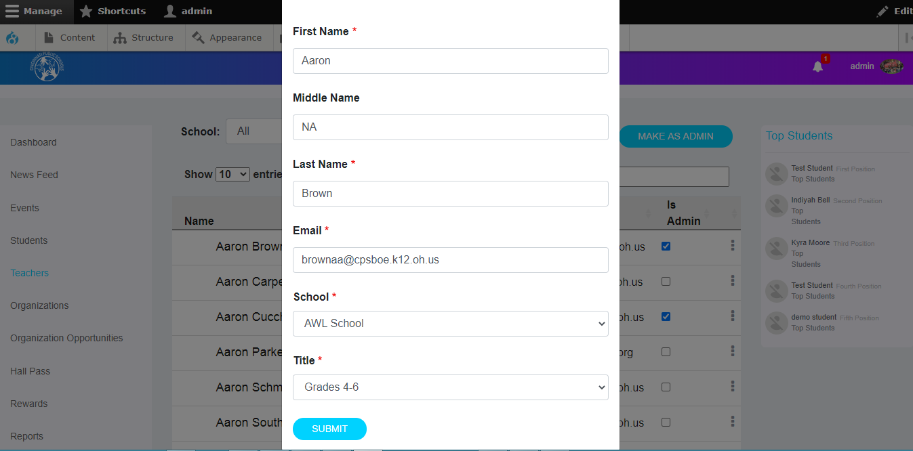

* In this window, you can edit the teacher’s information including first name, middle name, last name, email, school and title.
* Click the **Submit** button to save your changes.

## Organizations:

In the **Organizations** screen, you can view the organization requests from the various organizers and the admin can approve or reject the organizations. There are three tabs in this screen; Organization Approvals, Approved Organizations, Rejected Organizations.

### Organization Approvals tab:

In the **Organization Approvals** tab, the admin users can view the organizations posted by various organizers awaiting approval. On this screen, you can approve or reject organizations. You can also search for organizations and approve, reject, view or delete them.

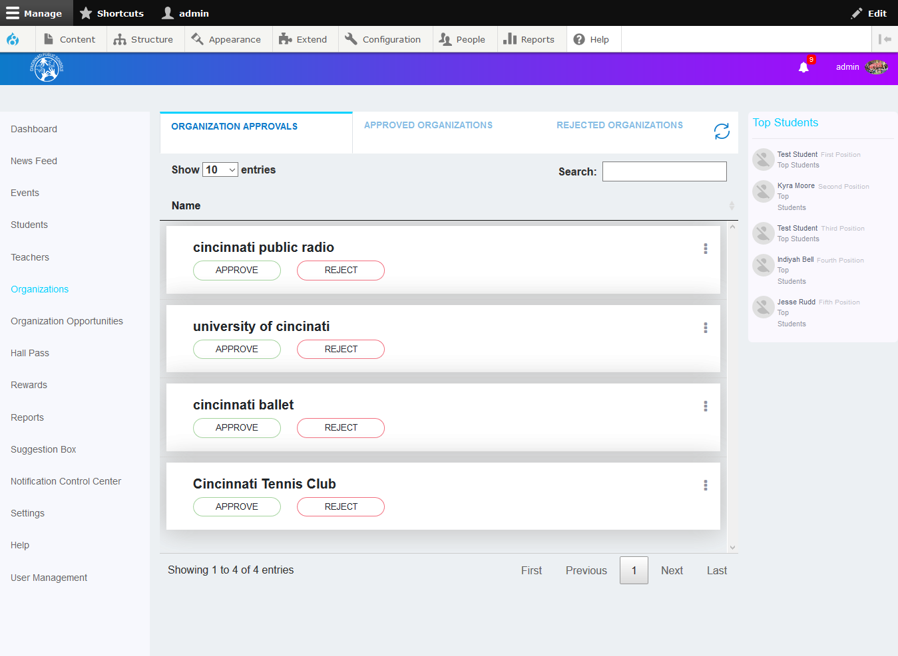

#### To approve or reject a organization:

* Select the organization from the list.
* Click the **Approve** or **Reject** buttons to approve or reject the organization.

**Note:** The Organization will receive an email from the administrator informing them of the approval with login credentials or rejection of the organization.

#### To view organization:

* Click the ellipsis icon as shown in the screen below.
* Click the **View Organization** button.

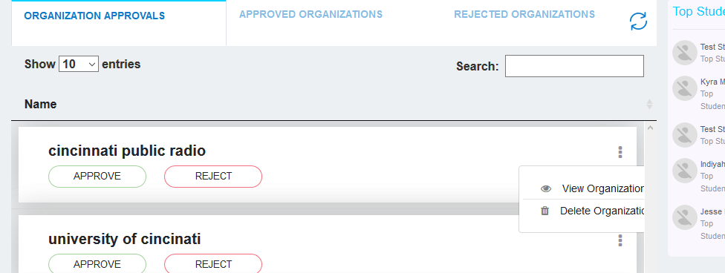

* The View Organization window is displayed.

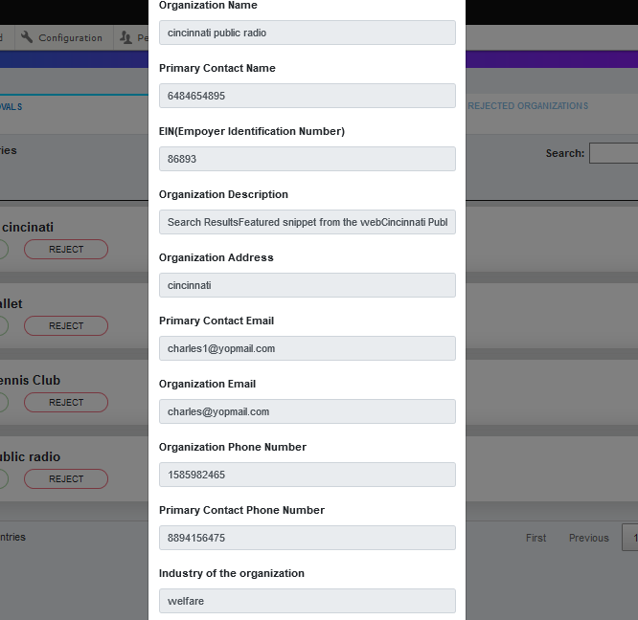

#### To delete organization:

* Click the ellipsis icon as shown in the screen above.
* Click the **Delete Organization** button.

### Approved Organizations tab:

In the **Approved Organizations** tab, the admin users can view the organizations approved by the admin users. On this screen, you can view, delete organizations and opportunities posted by that organization. You can also search for other organizations listed in this section.

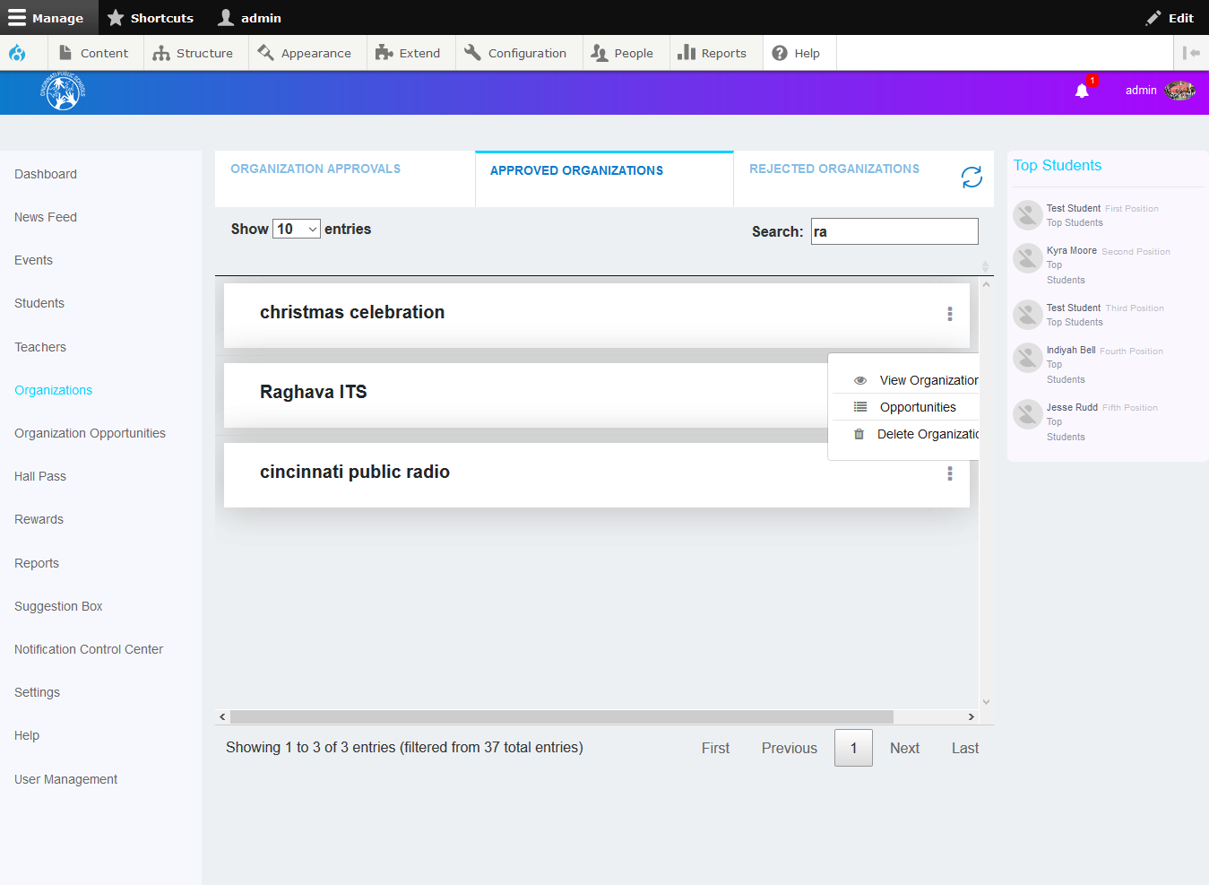

#### To view and delete organization:

* Click the ellipsis icon as shown in the screen above.
* Click the **View Organization** button and admin users can view the organization details
* Click the **Delete Organization** button to delete the organization.

#### To view Opportunities:

* Click the ellipsis icon as shown in the screen above.
* Click the **View Opportunities** button and the admin users will be redirected to the opportunities screen.
* There are three tabs in this screen; Opportunities Approvals, Approved Opportunities, Rejected Opportunities.

### Opportunities Approvals tab:

In the **Opportunities Approvals** tab, the admin users can view the various opportunities posted by the approved organizations. On this screen, you can approve or reject opportunities. You can also search for opportunities and view, approve or reject them.

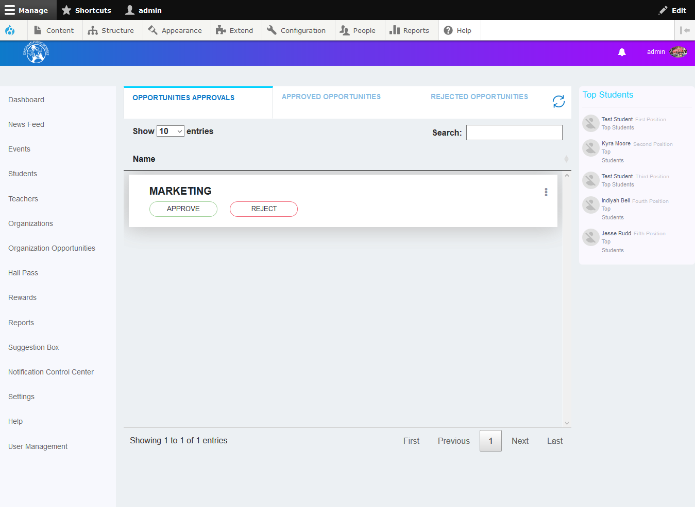

#### To reject opportunities:

* Click the **Reject** button as shown in the screen above.
* The **Rejection Feedback** window will display as shown below.

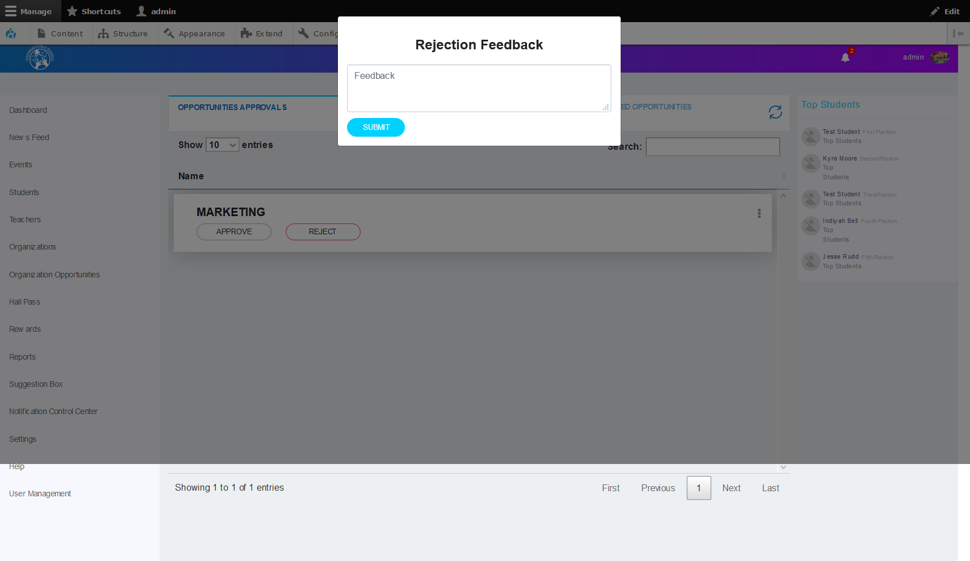

* Specify the rejection feedback in the respective text box.
* Click the **Submit** button to reject the opportunity.

**Note:** The organization will receive a notification and a message from the administrator informing them of the approval or rejection of the opportunity.

#### To view opportunities:

* Click the ellipsis icon as shown in the screen below.
* Click the **View Opportunities** button.

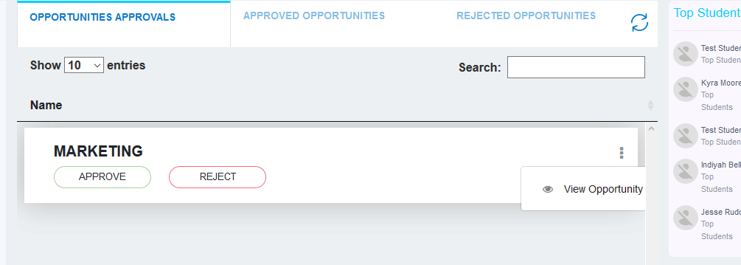

* The **View Opportunity** window is displayed.

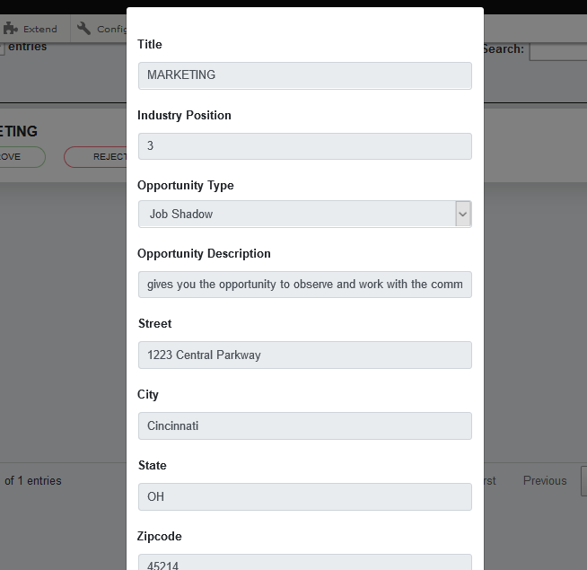

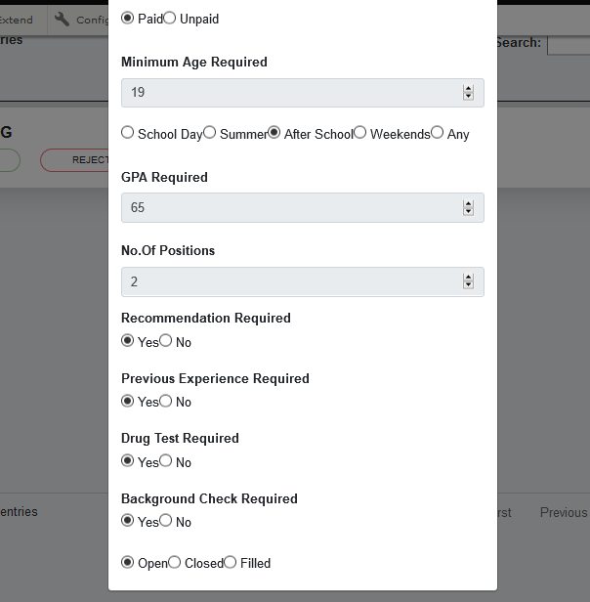

### Approved Opportunities tab:

In the **Approved Opportunities** tab, the admin users can view the opportunities approved by the admin users. On this screen, you can view various opportunities shown as above. You can also search for opportunities in this screen.

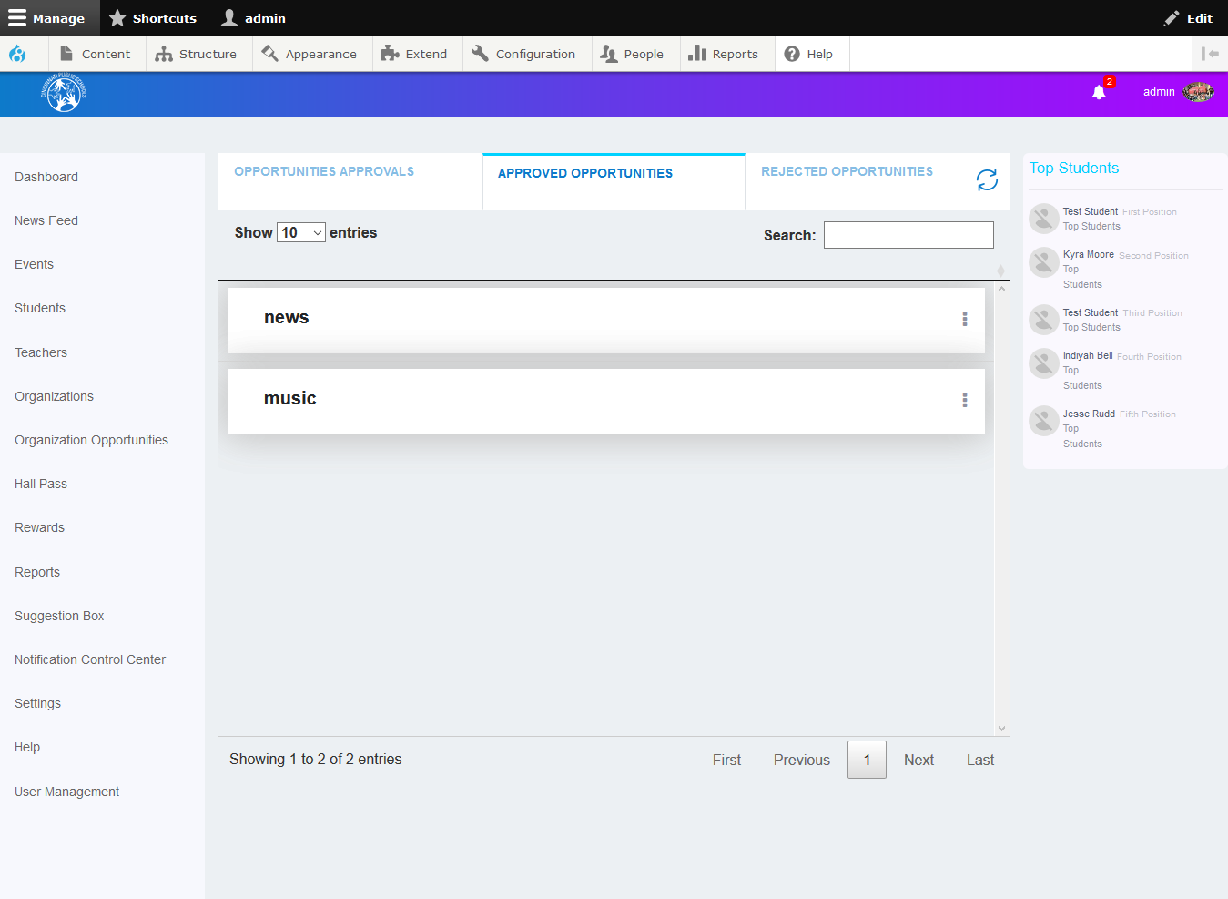

### Rejected Opportunities tab:

In the **Rejected Opportunities** tab, the admin users can view the opportunities rejected by admin users. On this screen, you can view Opportunities shown above. You can also search for various opportunities in this section.

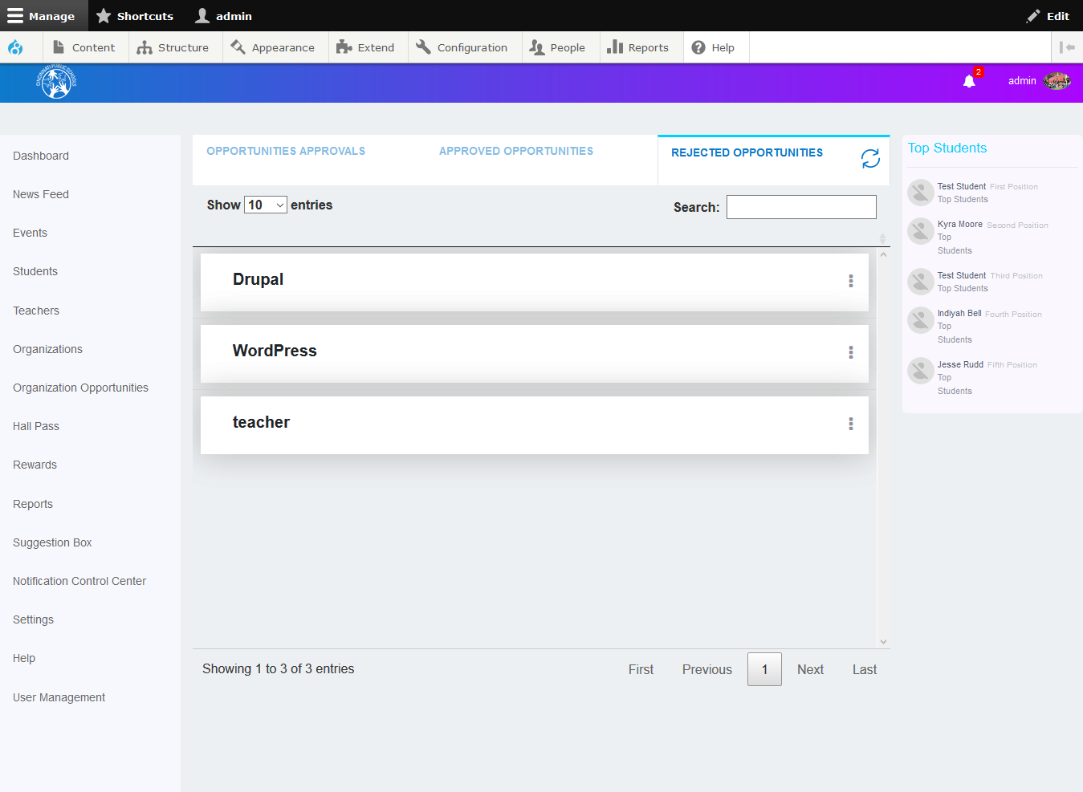

### Rejected Organizations tab:

In the **Rejected Organizations** tab, the admin users can view the organizations rejected by the admin users. On this screen, you can view or delete organizations. You can also search for various organizations in this screen.

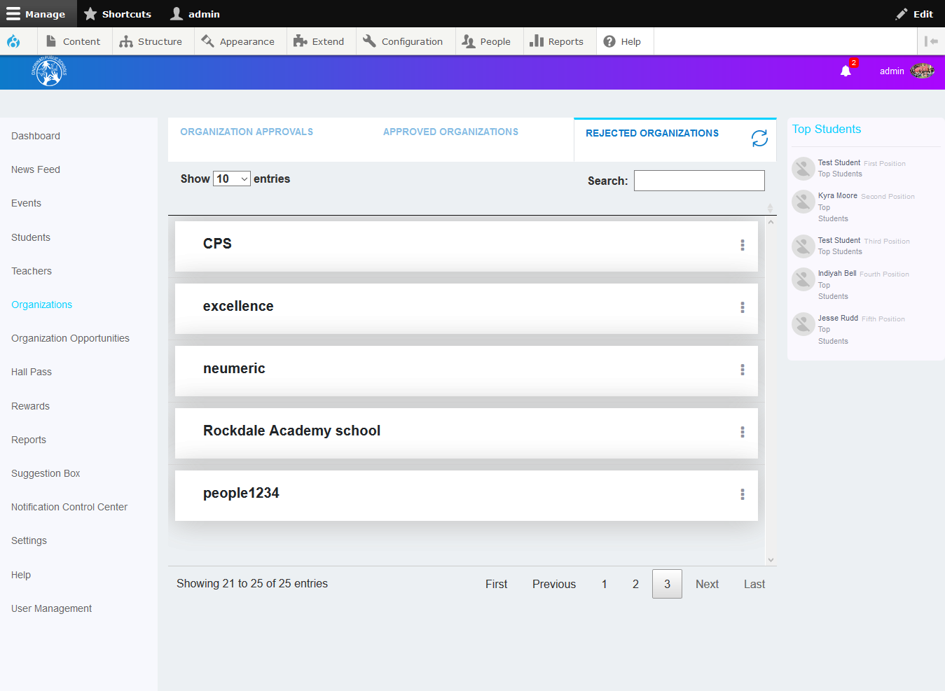

## Organization Opportunities:

In the **Organization Opportunities** screen, you can view the organization opportunities requests from various organizations, and the admin can approve or reject the opportunities. There are three tabs in this screen; Opportunities Approvals, Approved Opportunities, Rejected Opportunities.

### Opportunities Approvals tab:

In the **Opportunities Approvals** tab, the admin users can view the opportunities posted by the approved organizations. On this screen, you can approve or reject an opportunities. You can also search for opportunities and approve, reject or view them.

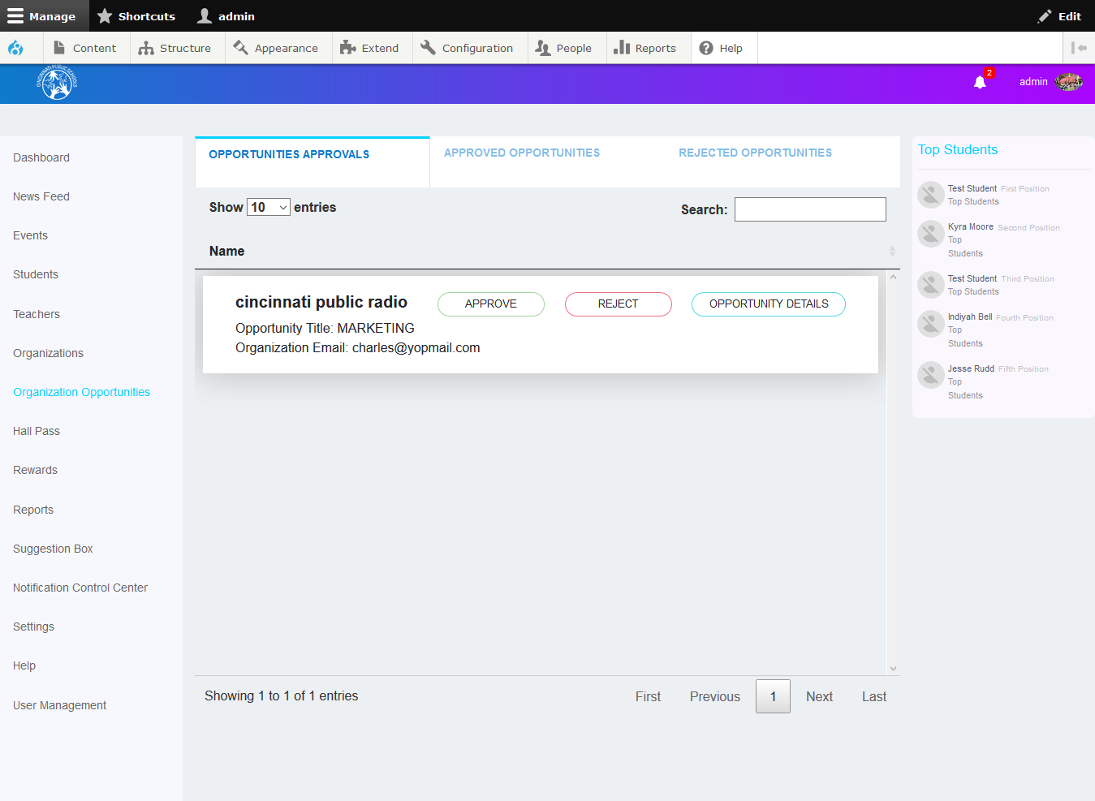

#### To reject opportunities:

* Click the **Reject** button as shown in the screen above.
* The **Rejection Feedback** window will display as shown below.

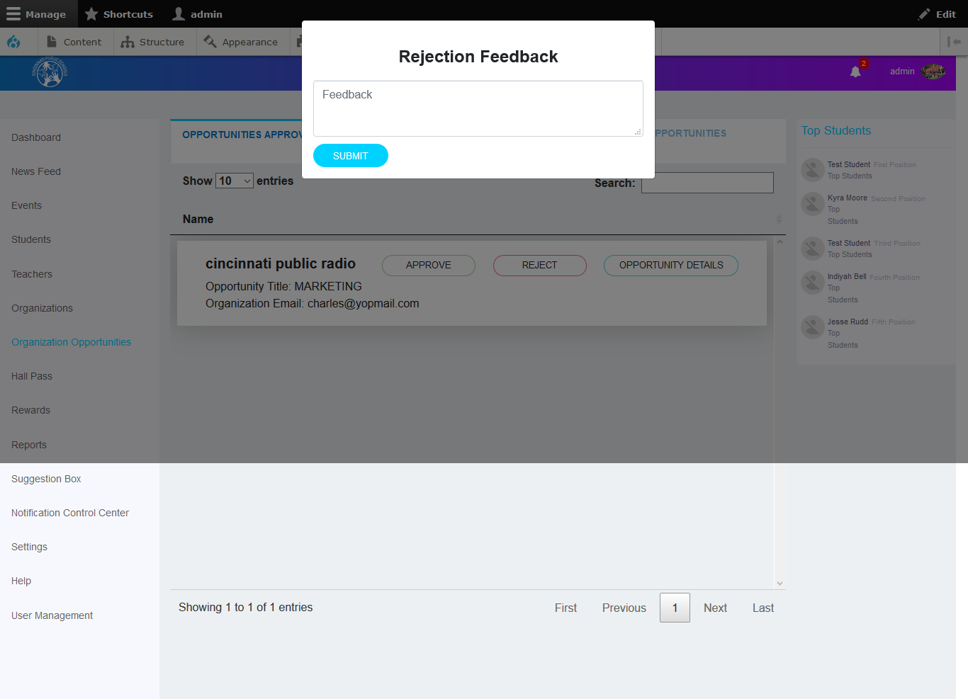

* Specify the reason for rejection / feedback in the respective text box.
* Click the **Submit** button to reject the opportunity

**Note:** The Organization will receive a notification and a message from the administrator informing them of the approval or rejection of the opportunity.

#### To view opportunities:

* Click the **Opportunity Details** button.
* Opportunity Details window will display the following screen.

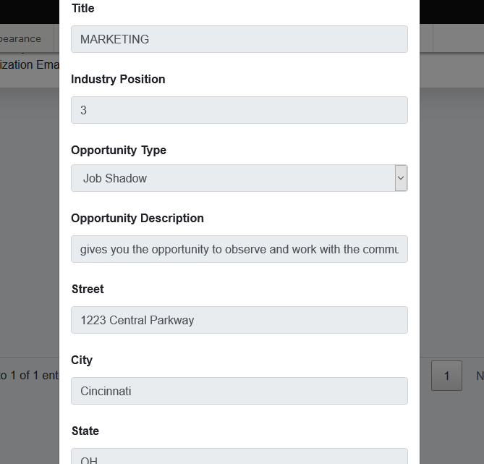

### Approved Opportunities tab:

In the **Approved Opportunities** tab, the admin users can view the opportunities approved by admin users. On this screen, you can view various opportunities as shown above. You can also search for various opportunities in this screen.

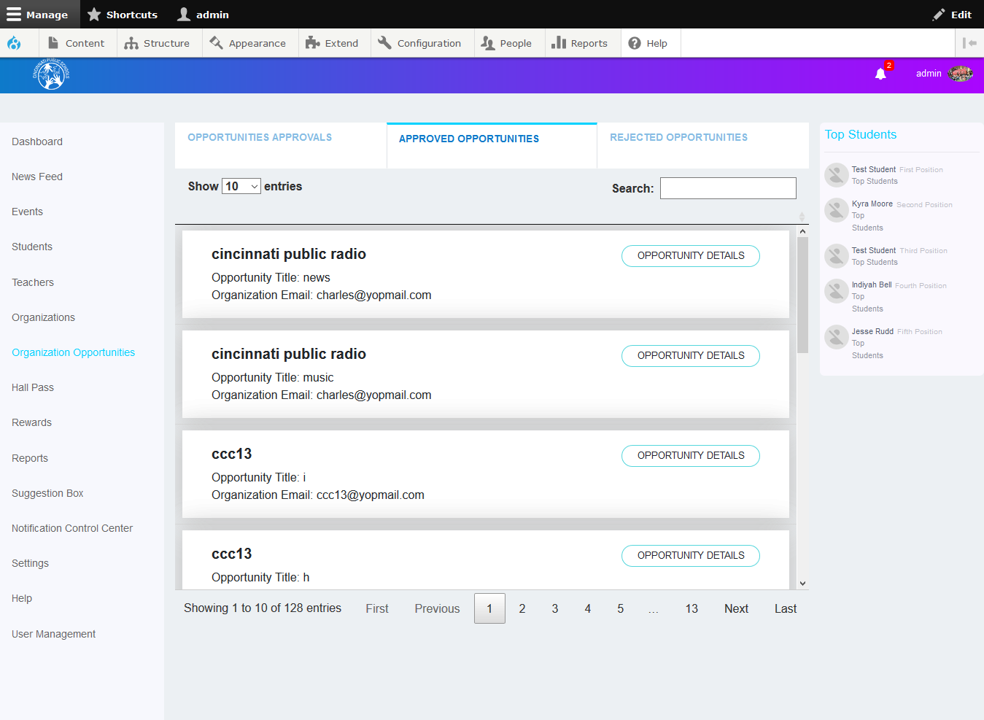

### Rejected Opportunities tab:

In the **Rejected Opportunities** tab, the admin users can view the various opportunities rejected by the admin users. On this screen, you can view various opportunities, as shown above. You can also search for various opportunities in this screen.

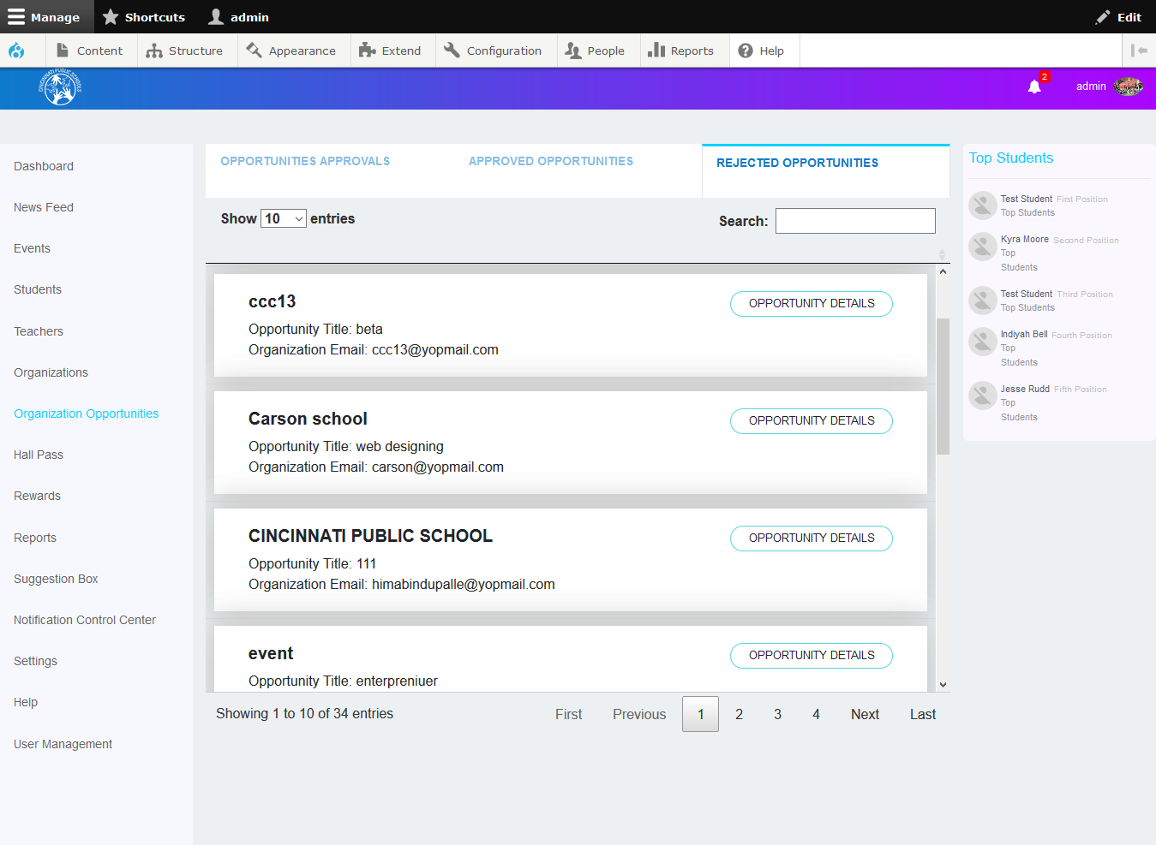

## Hall Pass

In the **Hall Pass** screen, you can view the hall pass requests from various students, and the admin can approve or reject the hall passes. There are two tabs in this screen; Published Hall Passes and Hall Pass Requests.

### Published Hall Passes tab

The **Published Hall Passes** tab displays all the hall passes that have a status associated with them. You can view the details of the hall passes including approved by, validity and destination hall.

### Hall Pass Requests tab:

In thistab, you can view all the hall pass requests along with their information including description, destination, valid from, expires on. You can approve or reject a hall pass.

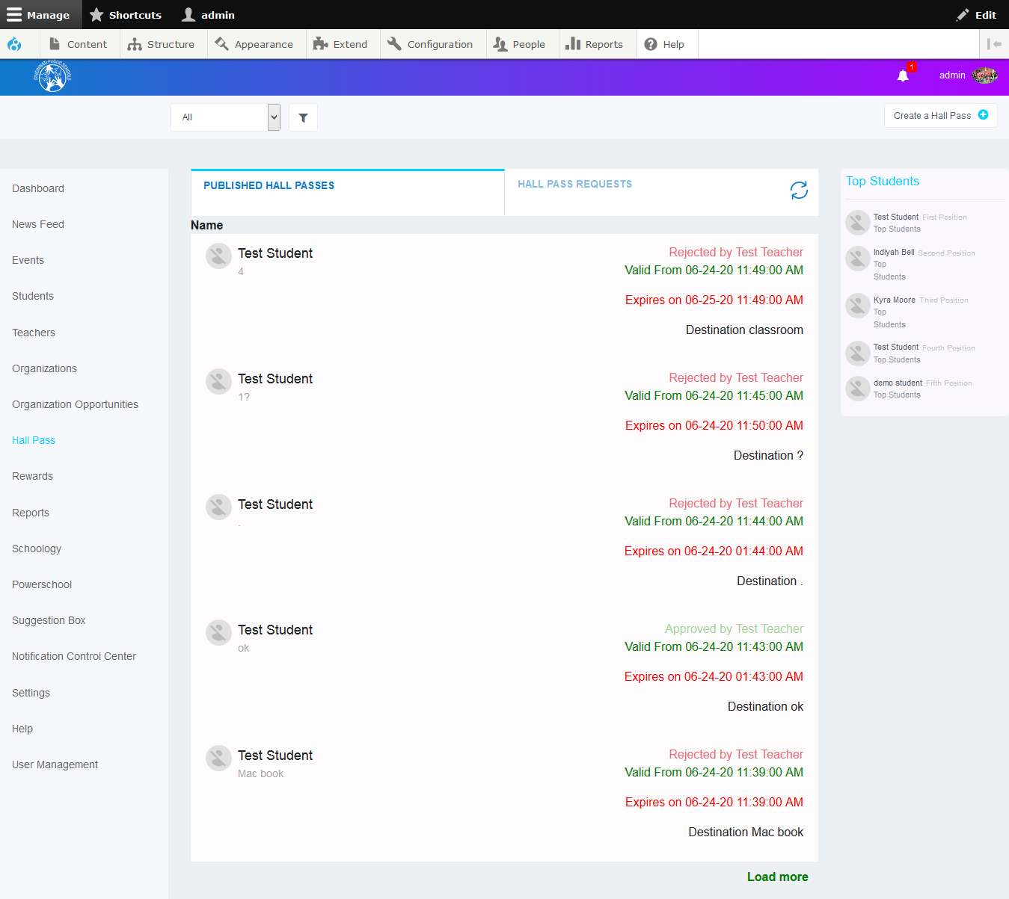

#### To approve or reject a hall pass:

* Select the hall pass from the list.
* Click the **Approve** or **Reject** buttons to approve or reject the hall pass, respectively.

You can also create and approve a hall pass for a student.

### To creating a New Hall Pass:

Click the **Create a Hall Pass** button at the top right corner of the Hall Passes screen. The Create Hall Pass window is displayed.

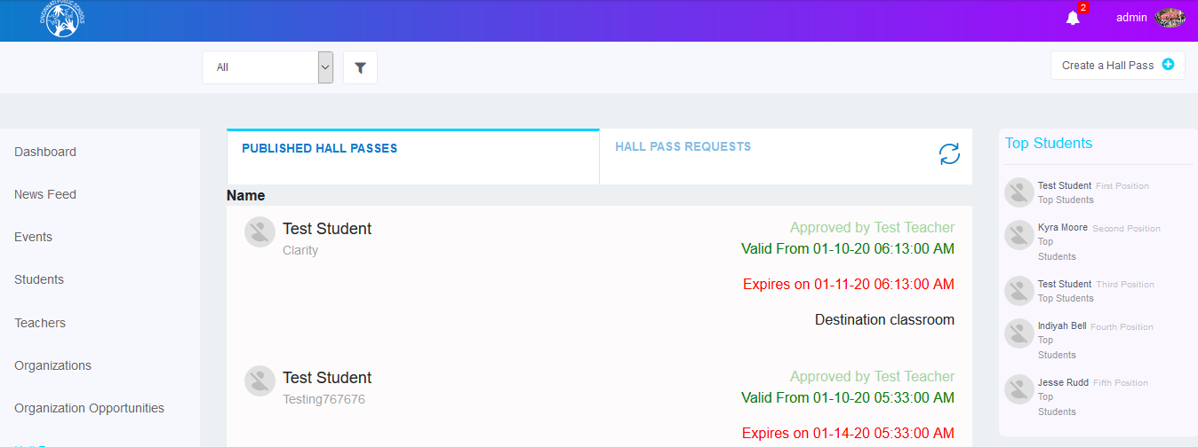

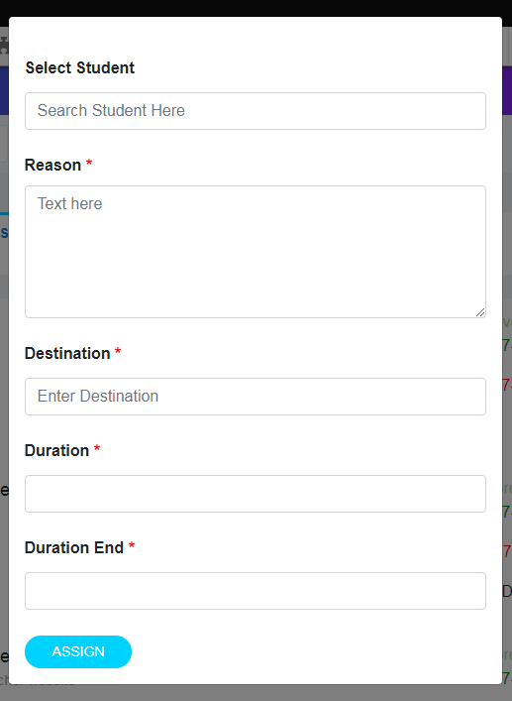

* Select the student after searching for the student with their name.
* Specify the reason and description in the respective text boxes.
* Specify the destination where the hall pass is to be used.
* Mention the start date and end date of the hall pass in the **Duration Start** and **Duration End** fields.
* Click the **Assign** button to publish a hall pass for the student.

## Rewards:

There are three tabs provided in the Rewards screen- Available Rewards, Assign Points and Assign Rewards for Action.

### Available Rewards tab:

You can view the list of all the students who have rewards to their credit. Click on the Number under the Reward level to view their details.

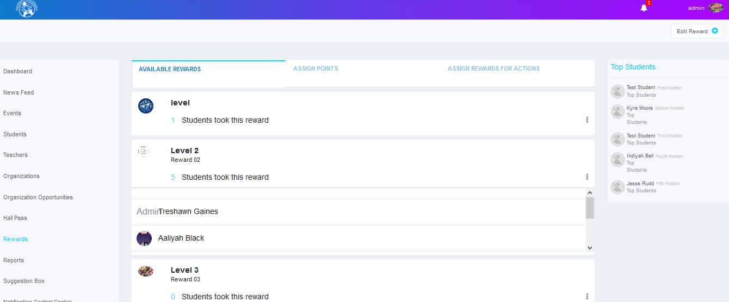

## *To edit reward’s details:*

* Click the ellipsis icon as shown in the screen below.
* Click the **Edit Reward** button.

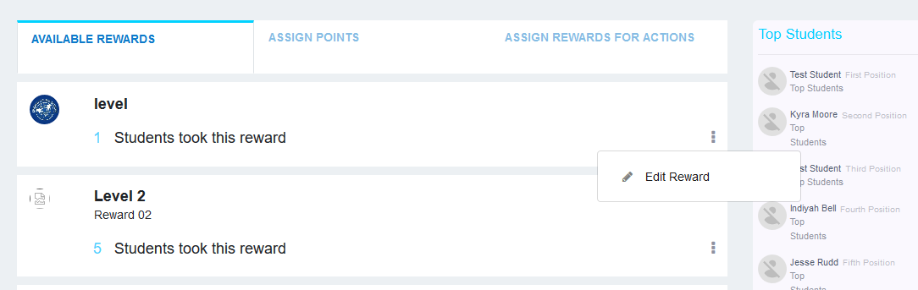

* The **Edit Reward** window will be displayed as shown.

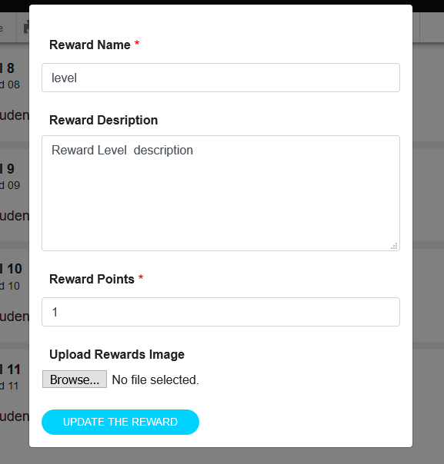

### Assign Points Tab

You can assign points to a single student or multiple students.

**To assign points to a single student:**

* Select the **For Single Student** radio button to assign rewards to a single student.
* Search for the student in the Select Student search field, assign the points and mention the reason for assigning the rewards.
* Click the **Assign** button.

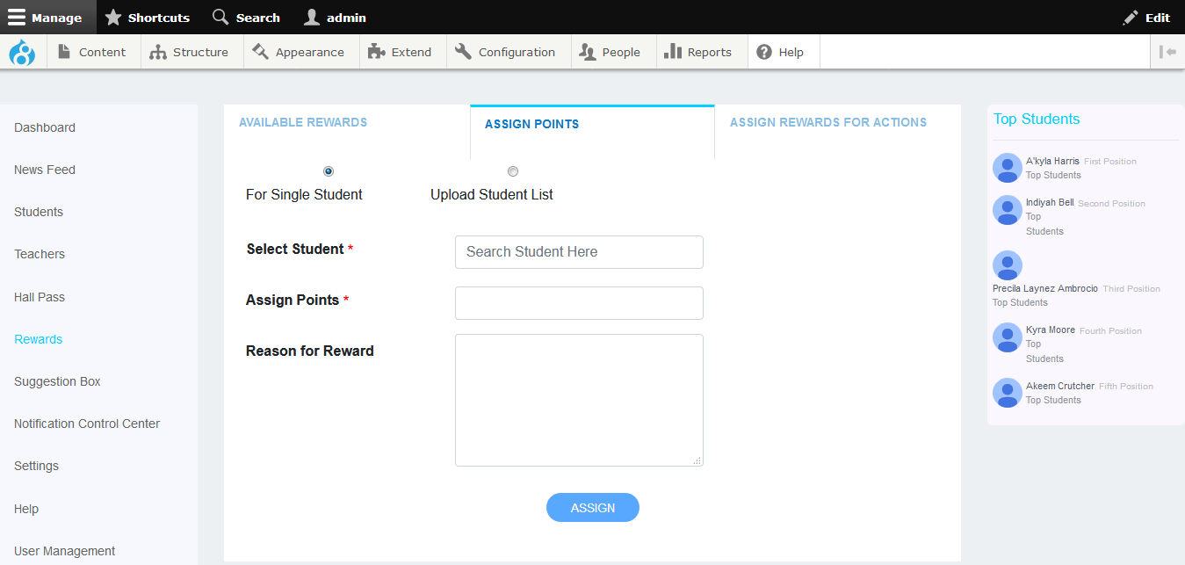

**To assign points to multiple students:**

* Select the **Upload Student List** radio button.
* Browse for the rewards file by clicking the Browse button.
* Rewards File Format Sample is available. Click on this link to download sample format to fill the details and upload it.
* Click the **Submit** button.

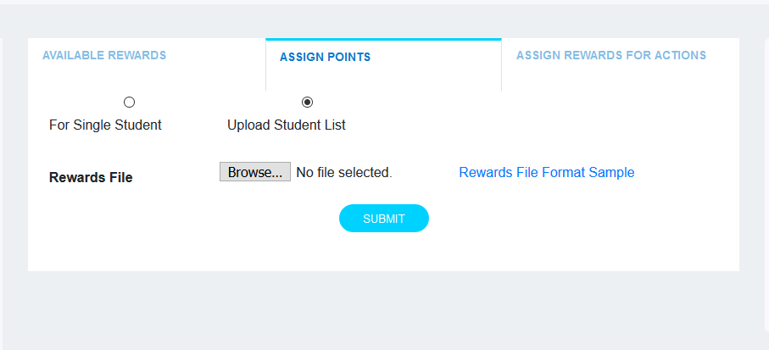

### Assign Rewards for Action Tab:

You can assign bonus points for various actions including Apply for Jobs, delete post, Delete Suggestion, hall pass approvals, like post, news feed approval, posting comment approval, suggestion comments approval, suggestion like post , suggestions feed approval, power school attendance, schoology assignment.

**To add points for Power School Attendance/Schoology Assignment:**

When Click on **Add Points** button, two input fields will add to add points. These points will display in schoology and power school. These input points also have **Remove** button. The authorized Admin can add/remove points.

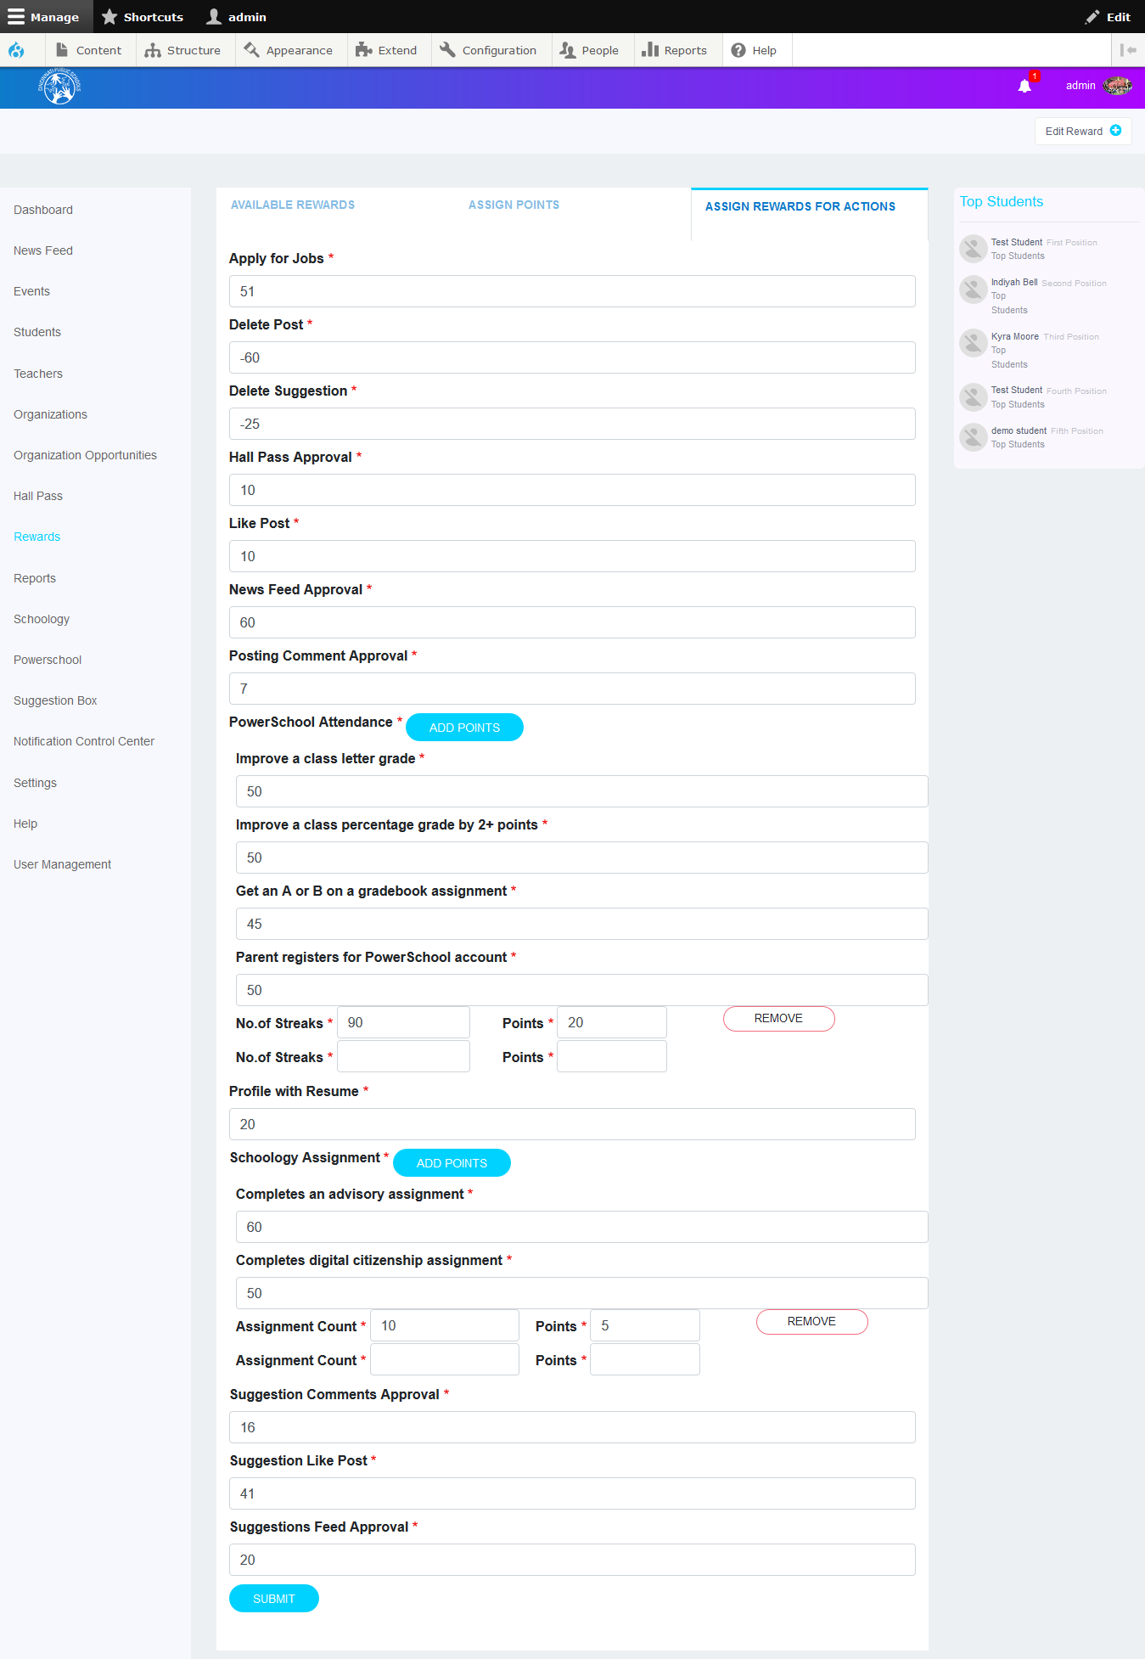

## Reports:

* You can view the **Reports** by selecting the option as shown below. Various reports include the number of opportunities by organizations, number of students with profiles, number of matches with at least three (3) stars, top industries of interest.

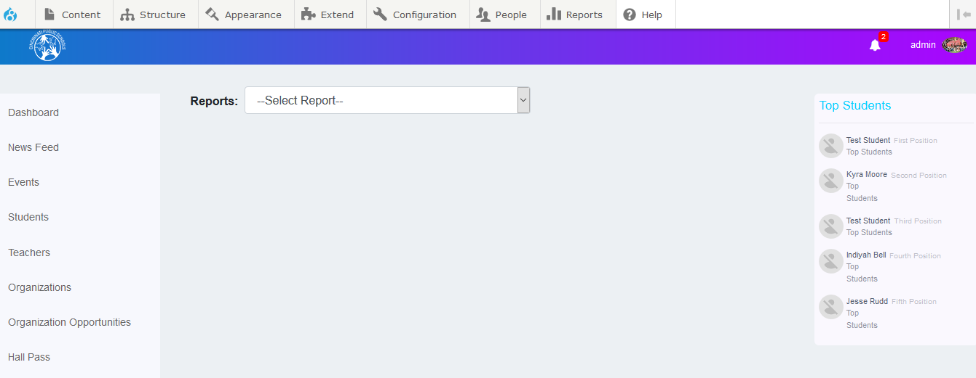

* You can select any one of the options to view or print relative information as shown below. Also, you can search by organization name, email-id and other parameters

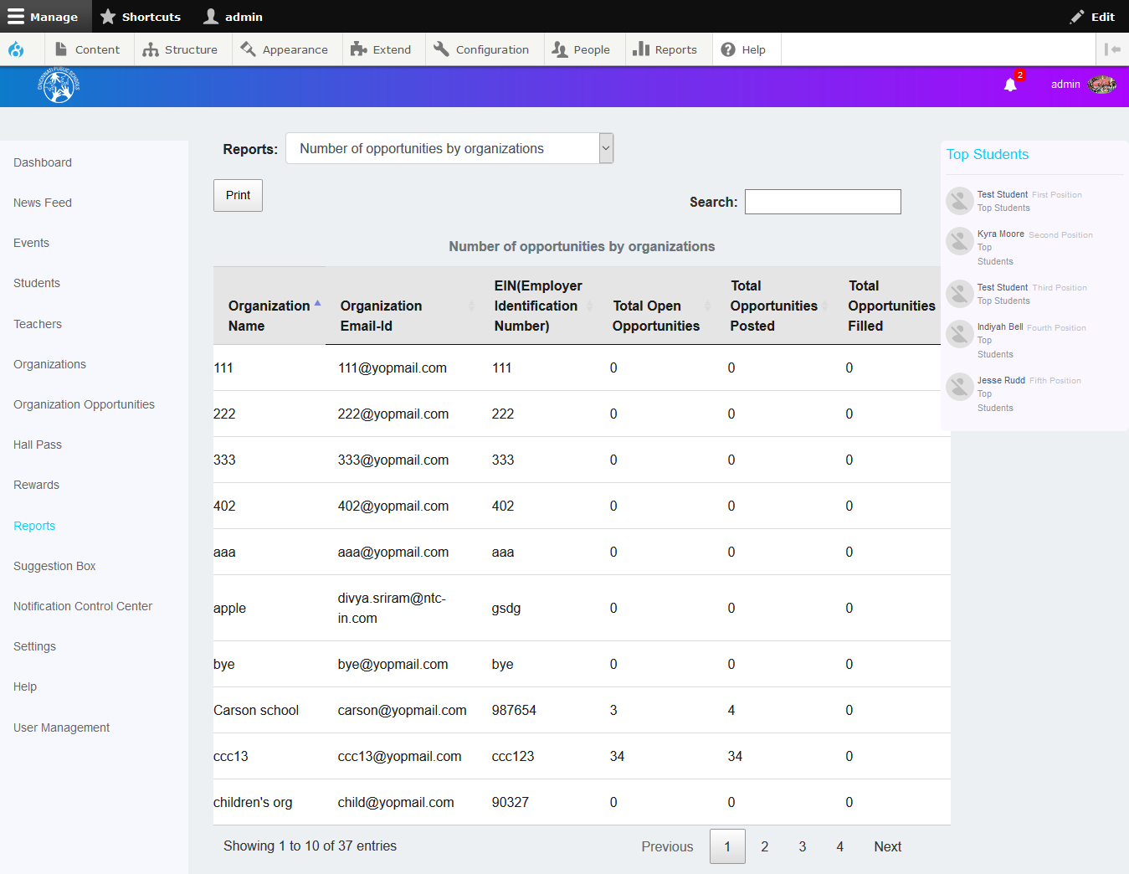

## Schoology:

* You can view the List of assignmentsby selecting the option as shown below. When students complete the various assignments including Completes an advisory assignment, Completes digital citizenship assignments and Various Turned in schoology assignments, the admin can reward points to the students. The various turned in schoology assignments options, which we added in Assign Rewards Points For Actions tab in **Rewards,** is displayed in this screen.

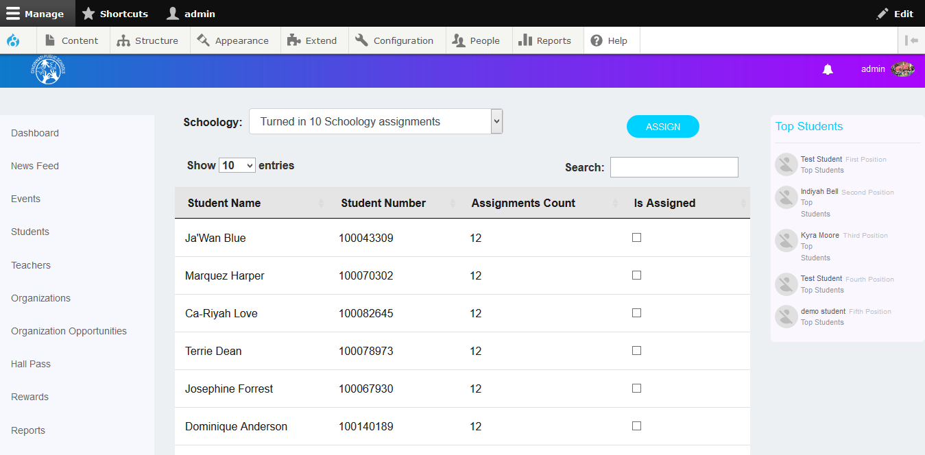

### Assign Points for Students:

Check the **Is Assigned** checkboxes corresponding Students, then click on **ASSIGN** button, then based on selected Schoology type, points will add to selected students.

Admin can also search for particular students by student name, student number.

## Power School:

* You can view the List of Power Schools assignments by selecting the option in dropdown. When students eligible to various Power School add points including Get an A or B on a gradebook assignment, improve a class letter grade, Improve a class percentage grade by 2+ points, Parent registers for Power school account and various No Absences days, the admin can reward points to the students. The various No Absences days, which are we added in Assign Rewards Points For Actions tab in **Rewards**. Date range picker is also there to filter students between two dates.

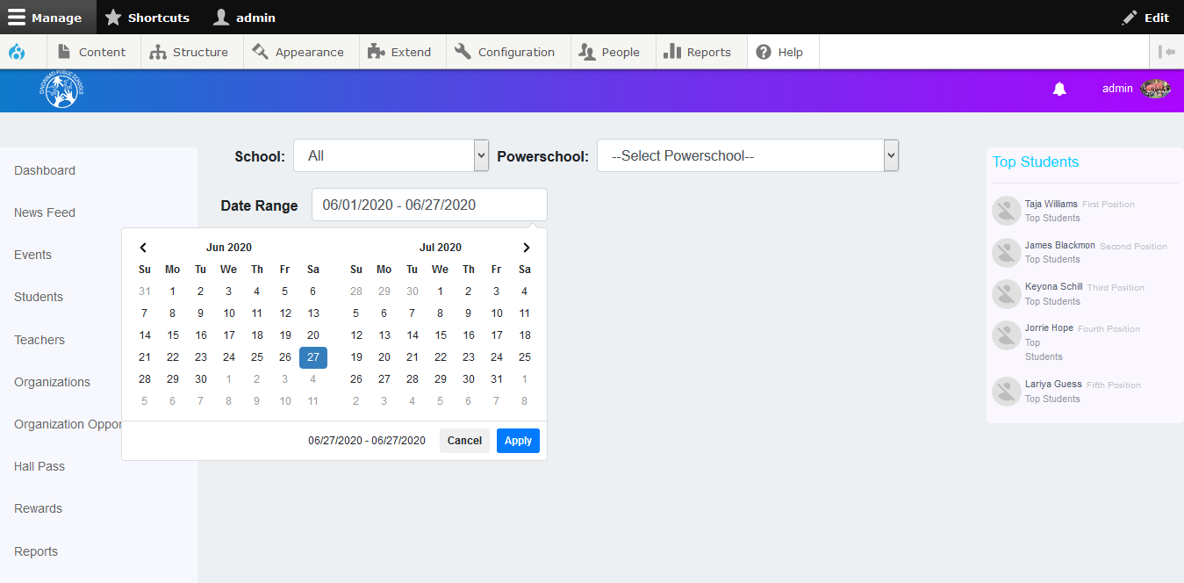

### Assign Points for Students:

Check the **Assign** checkboxes corresponding Students, then click on **ASSIGN** button, then based on selected Power School type, points will add to the selected students.

Admin can also search for particular students by student name, student number and date.

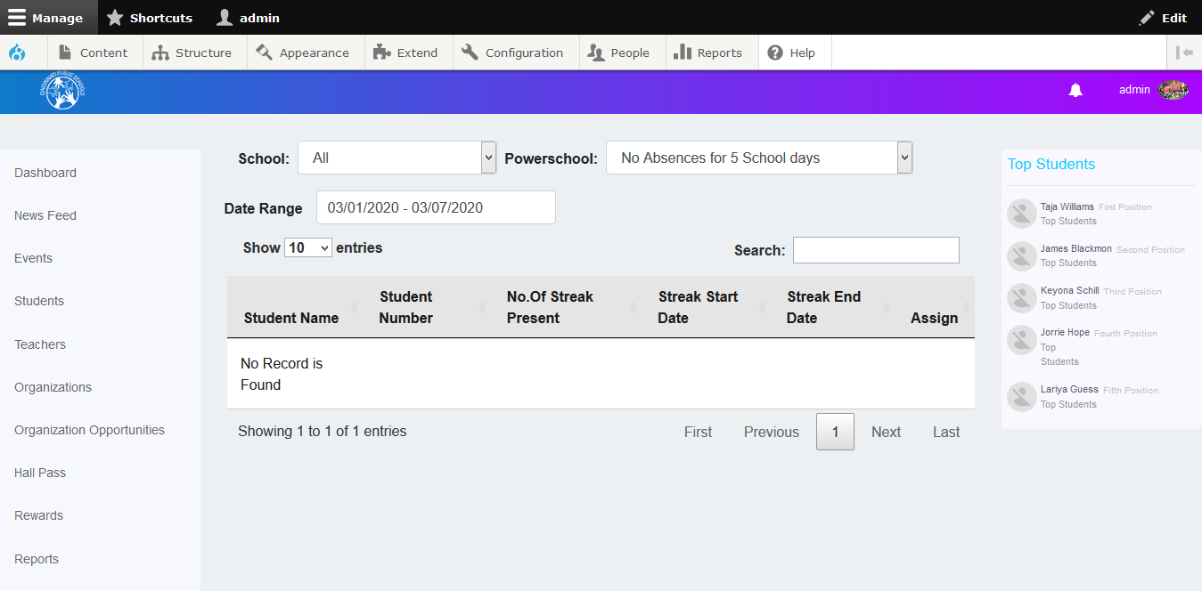

### Suggestions Box:

In the Suggestions screen, you can view the suggestion requests from the students, and the admin can approve or reject the suggestions. There are three tabs in this screen; Suggestion Feed, Approve Suggestions, Approve Comments.

### Suggestion Feed tab:

In the **Suggestion Feed** tab, the admin users can view various student suggestions approved by the admin users. On this screen, you can view suggestions and the likes, comments for each suggestion. You can also search for suggestions to view or delete them.

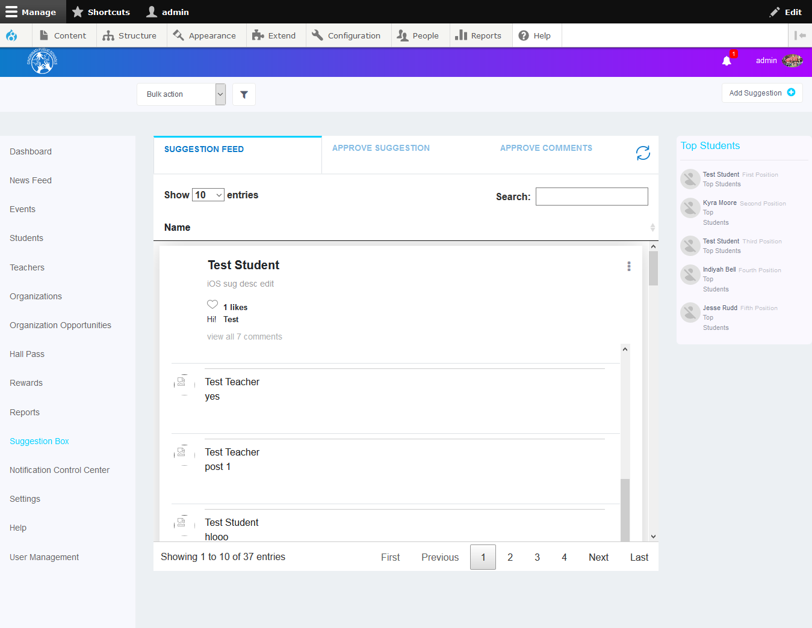

## *To Post a comment to a suggestion:*

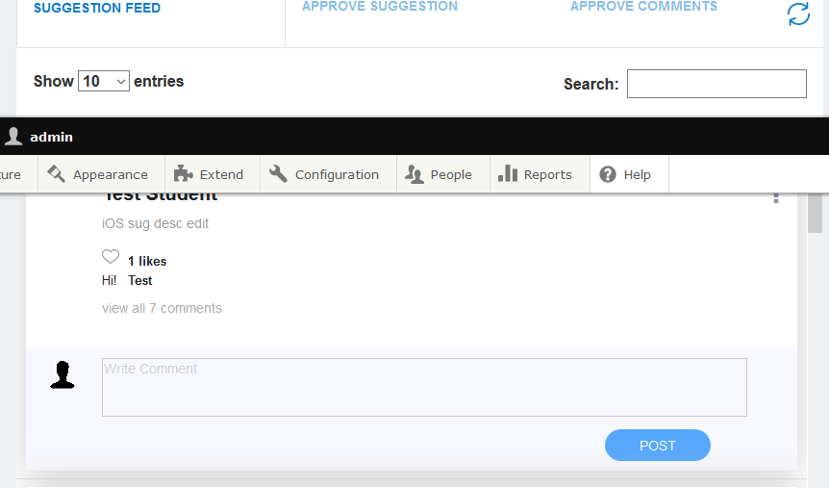

* Specify the comment in the respective text box.
* Click the post button to psot the comment.

## *To delete suggestion:*

* Click the ellipsis icon as shown in the screen below.
* Click the **Delete Suggestion** button.

**Note:** The student will receive a notification and a message from the administrator informing them of the like or comments of a suggestion.

### Approve Suggestion tab:

In the **Approve Suggestion** tab, the admin users can view the suggestions request from the students. On this screen, you can approve or delete a suggestion. You can also search for suggestions to approve or reject them.

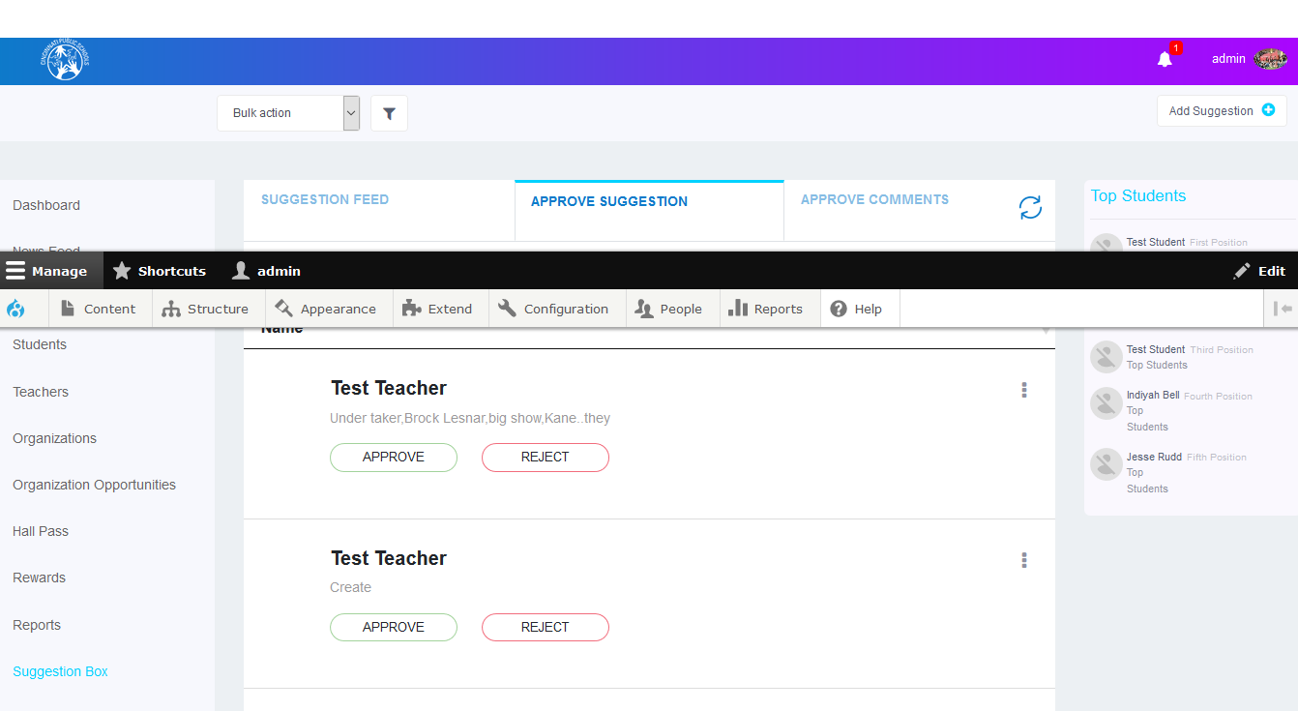

**Note:** The student will receive a notification and a message from the administrator informing them of the approval or reject of their suggestion.

### Approve Comments tab:

In the **Approve Comments** tab, the admin users can view the suggestion comments from the students and teachers. On this screen, you can approve or reject comments. You can also search for suggestion comments to approve or reject them.

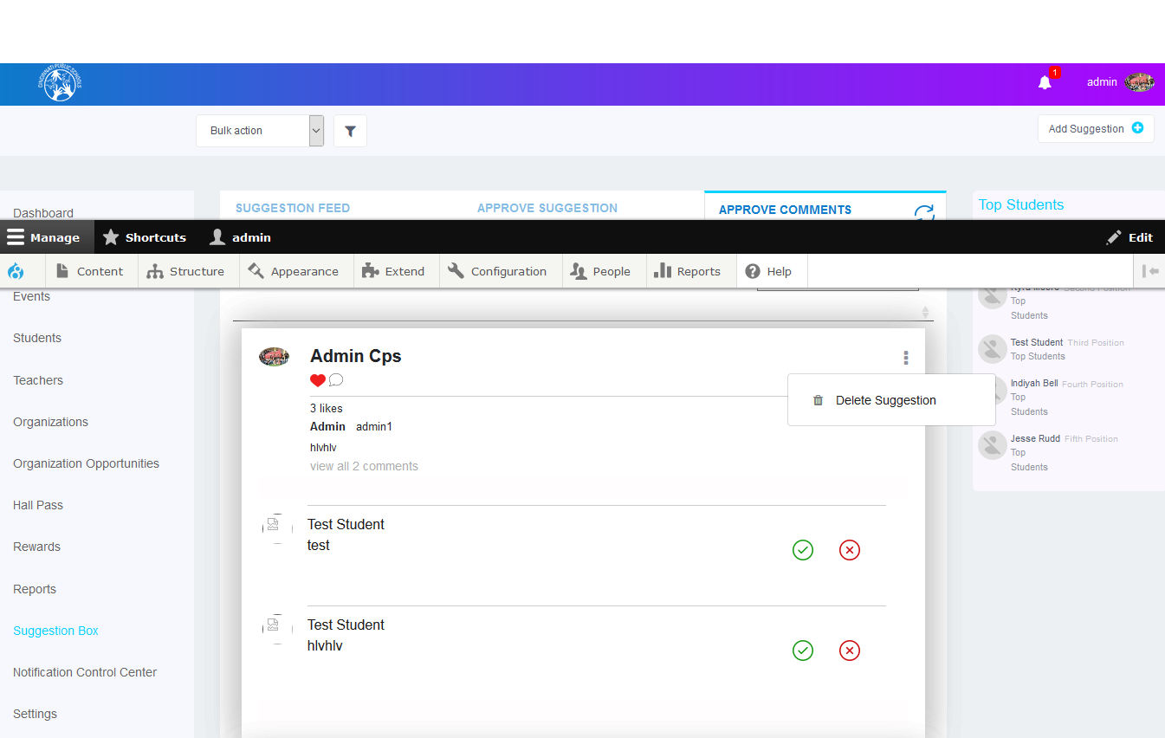

## *To delete suggestion:*

* Click the ellipsis icon as shown in the screen above.
* Click the **Delete Suggestion** button.

**Note:** The student will receive a notification and a message from the administrator informing them of the approval or rejection of a comment to that suggestion.

Notification Control Center: (Future Implementation)

### Settings:

In **School Theme tab,** the admin users can change the **School Theme** for each school. When select school if school has theme it will display preview at right side and **Set Default Theme** button at bottom. If selected school does not have particular theme, default theme will apply authomatically.

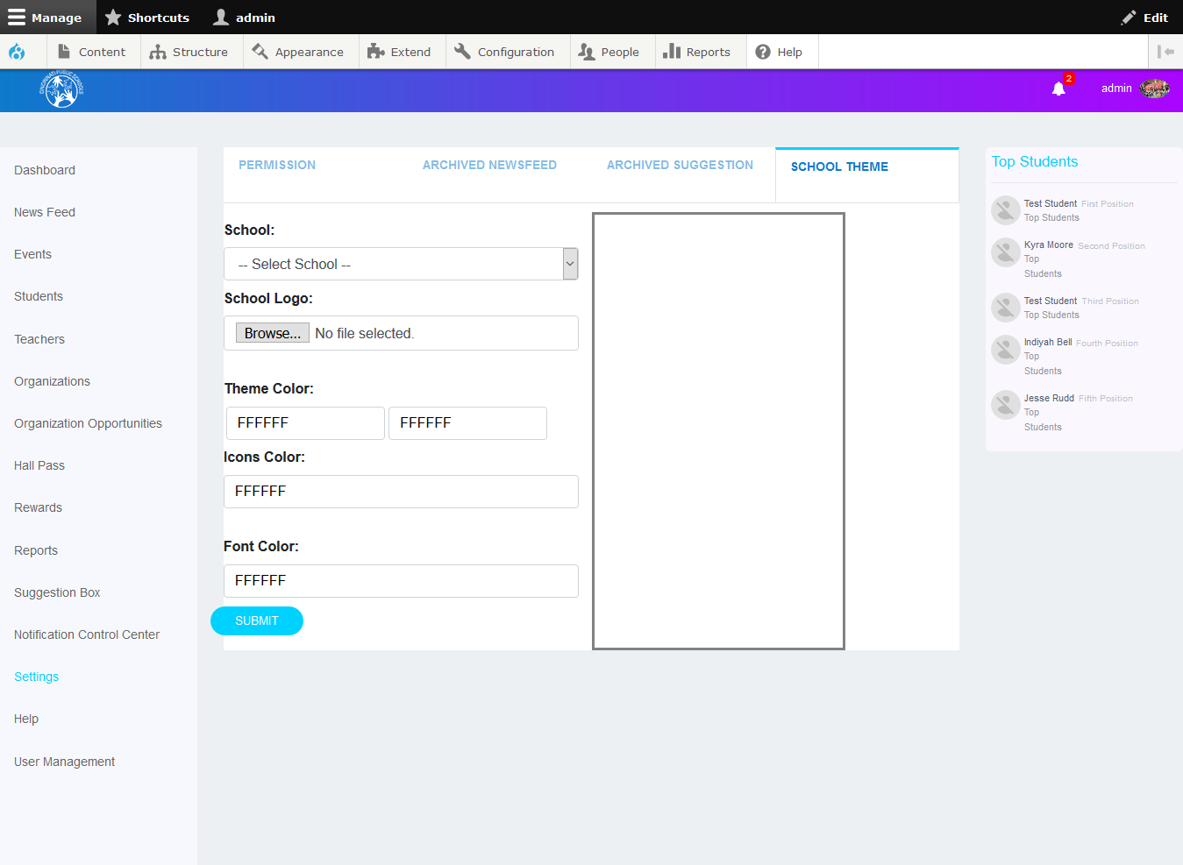

## Help

From this screen, you can describe the various categories including news feeds, notifications and rules. These descriptions will be displayed on the respective student and teacher dashboard **Help** screens.

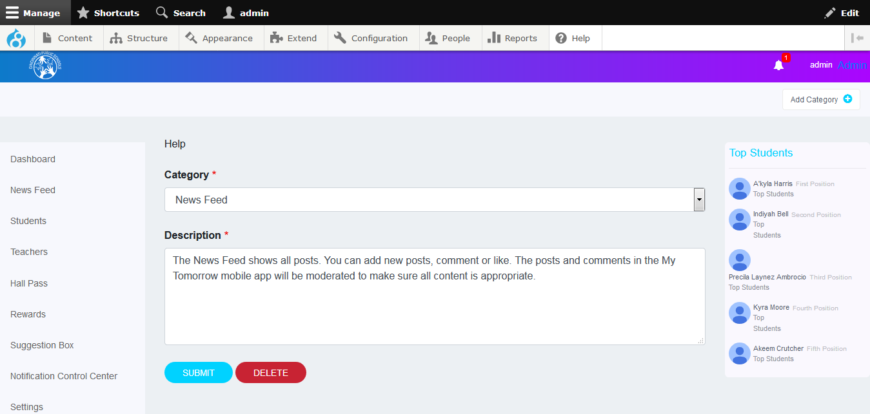

You can add a new category from this screen.

**To add a new category:**

* Click the Add Category button, located at the top right corner of the screen.
* The **Add Category** window is displayed.
* Mention the name of the category and its description.
* Click the **Assign** button.

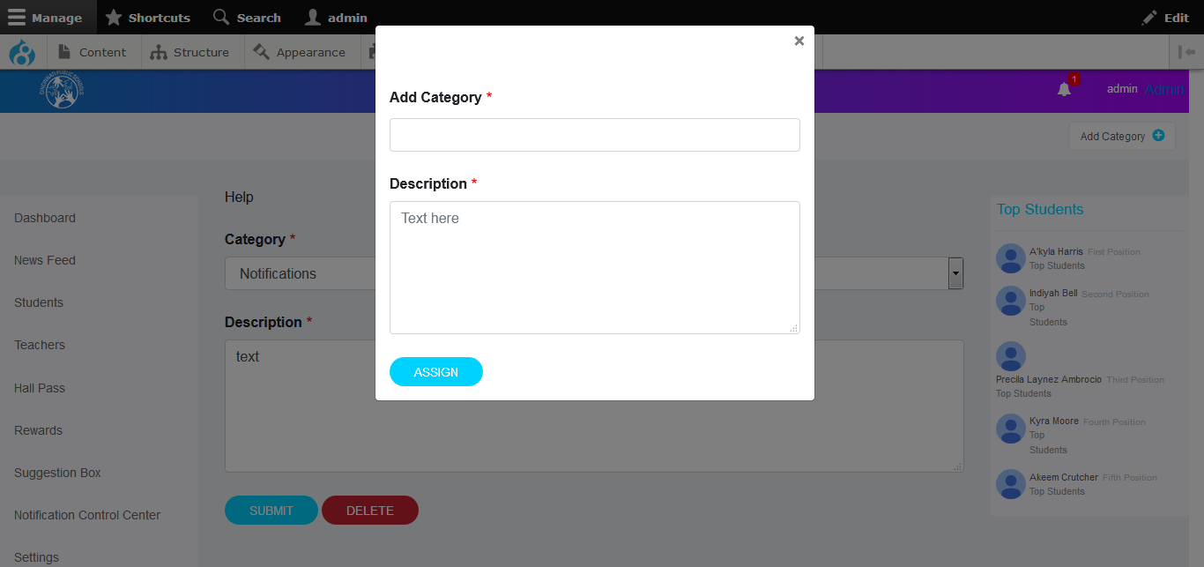

You can also delete a category.

**To delete a category:**

* Select the category from the **Category** drop-down list in the Help screen.
* Click the **Delete** button below the **Description** text box.

User Management: (Future Implementation)

# 2. Organization

## Logging in:

To log in to the Cincinnati Public Schools website as an organizer, perform the following steps:

* Enter valid username and password in the respective text boxes and click the **Login** button.
* You will be redirected to the admin Dashboard screen.



## Organizer Dashboard:

When you log in as an organizer, you can view the organization details in the respective textboxes on your Dashboard screen.

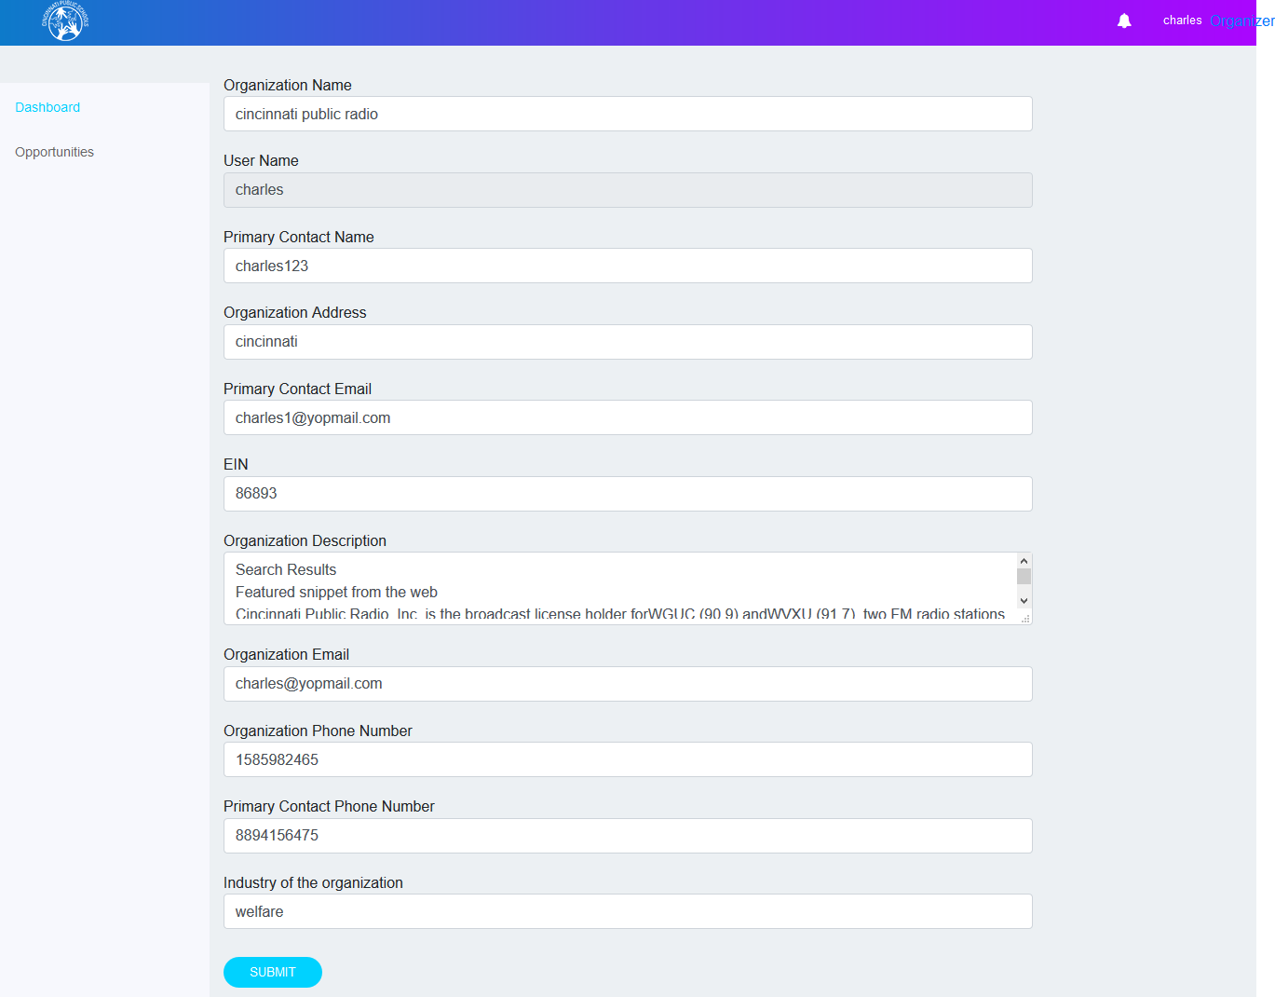

## *To edit organization:*

* In this window, you can edit the Organization’s information.
* Click the **Submit** button to save your changes.

**Note:** The admin will receive a notification from the organization informing them of the edit in the information of the organization.

### Opportunities:

The organizer can view the Opportunities, if organization is in approved state. There are three tabs in this screen; Opportunities Approvals, Approved Opportunities, Rejected Opportunities

### Opportunities Approvals tab:

In the Opportunities Approvals tab, the organizer can view their own opportunities which are not approved. On this screen, you can edit or delete opportunities. You can also search for opportunities to edit or delete them.

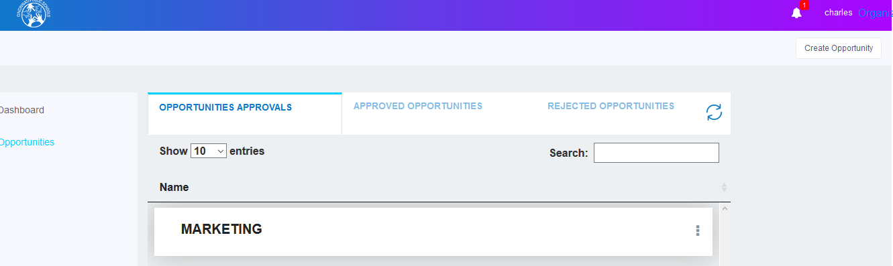

### To create Opportunity:

* Click the **Create Opportunity** button at the top right corner of the events screen. The Create Event window is displayed.

## *To edit opportunity:*

* Click the ellipsis icon as shown in the screen below.
* Click the **Edit Opportunity** button.

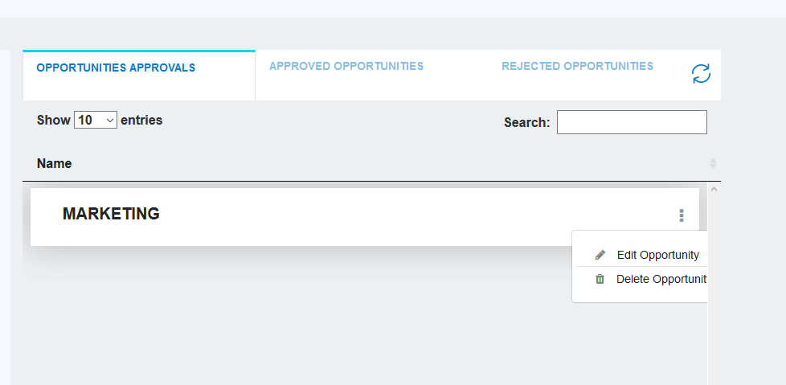

* The Edit window will display shown below.

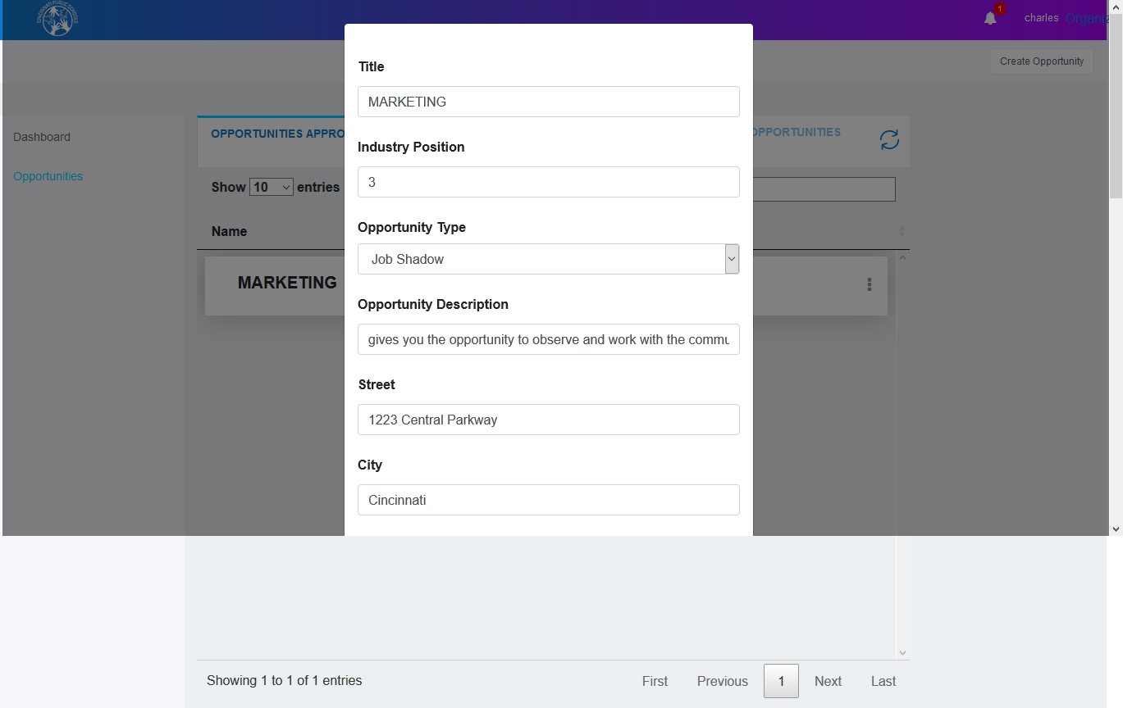

* Specify the details in the respective text boxes.
* Click the **Submit** button.

**Note:** The admin will receive a notification from the organization informing them of the edit in the opportunity.

## *To delete opportunity:*

* Click the ellipsis icon as shown in the screen below.
* Click the **Delete Opportunity** button.



### Approved Opportunities tab:

In the **Approved Opportunities**, the tab organizer can view various opportunities which are approved by the administrator. On this screen, you can view students listed and delete opportunities. You can also search for opportunities to view students or delete them.

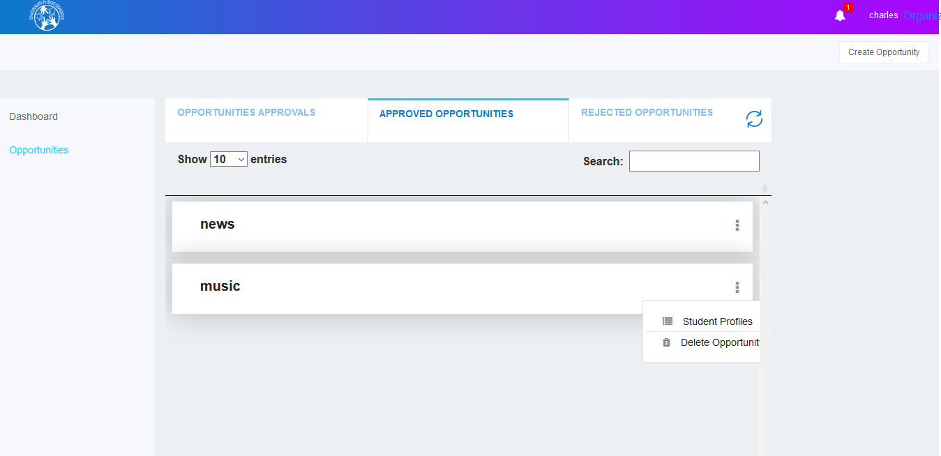

## *To delete opportunity:*

* Click the ellipsis icon as shown in the screen above.
* Click the **Delete Opportunity** button.

#### To view Students:

* Click the ellipsis icon as shown in the screen above.
* Click the **Student Profiles** button, then organizer will be redirected to the student profiles screen.
* There are three tabs in this screen; Interested Students, Selected Students, Rejected Students.

### Interested Students tab:

In the **Interested Students** tab, the organizer can view the students who are interested in an opportunity. On this screen, you can approve, reject or view students. You can also search for students to approve, reject or view their details.

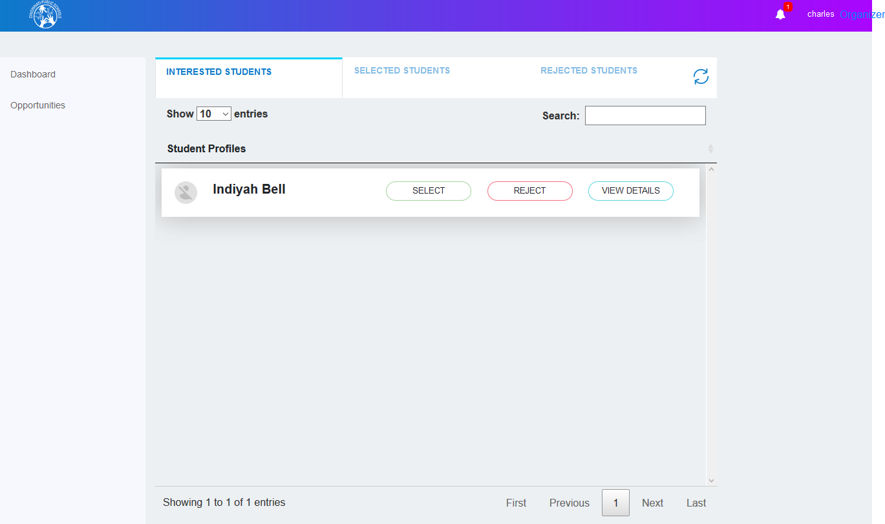

#### To select students:

* On the Interested Students tab, select the student to be selected.
* Click the **Select** button at the right side of the student.

#### To reject students:

* On the Interested Students tab, select the student to be rejected.
* Click the **Reject** button at the right side of the student.

**Note:** The students will receive a notification and a message from the organization informing them of the approved or rejected.

#### To view student’s details:

* On the Interested Students tab, select the student to view.
* Click the **View Details** button at the right side of the student.
* Details will be shown as follows.

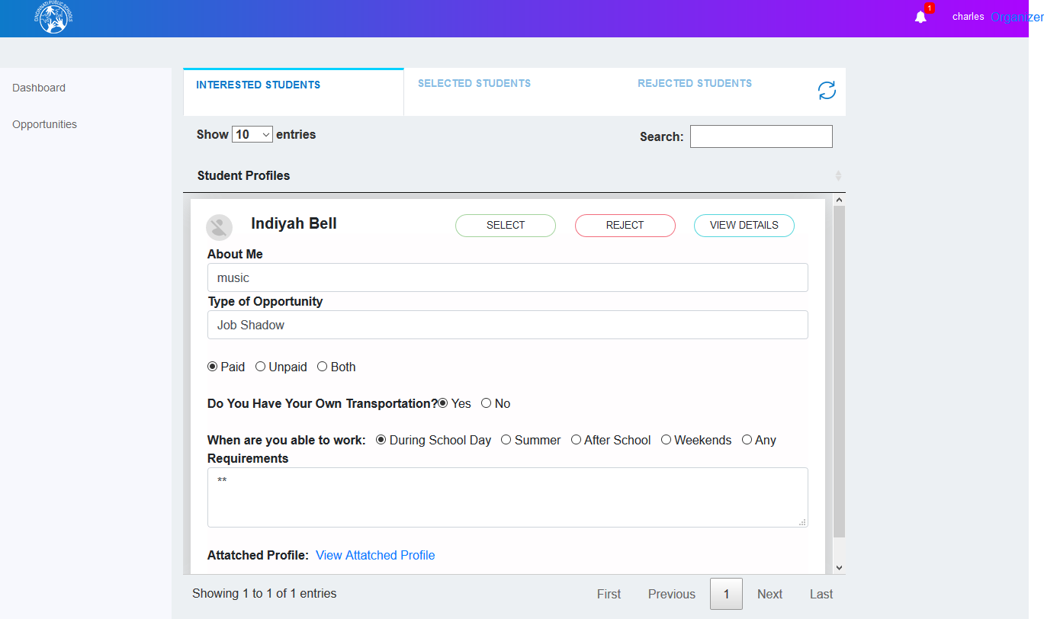

### Selected Students tab:

In the **Selected Students** tab, the organizer can view the students who are selected by organizer. On this screen, you can view students and also search for students to view their details.

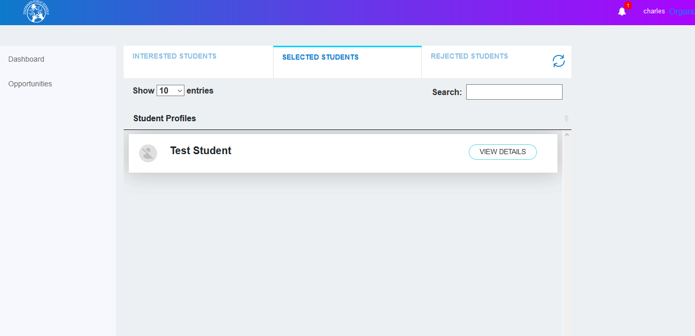

#### To view students details:

* On the Selected Students tab, select the student to view the details.
* Click the **View Details** button at the bottom of the student tab.
* Details will show as follows.

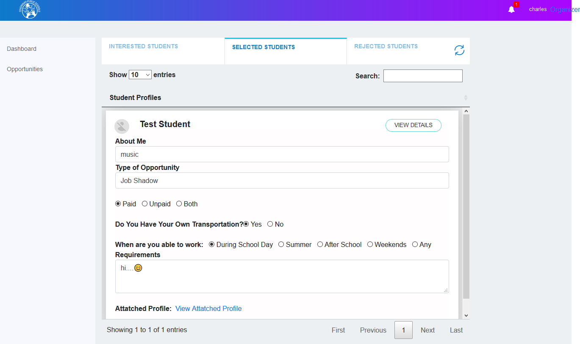

### Rejected Students tab:

In the **Rejected Students** tab, the organizer can view the students who are rejected by the organizer. On this screen, you can view students and also search for students to view their details.

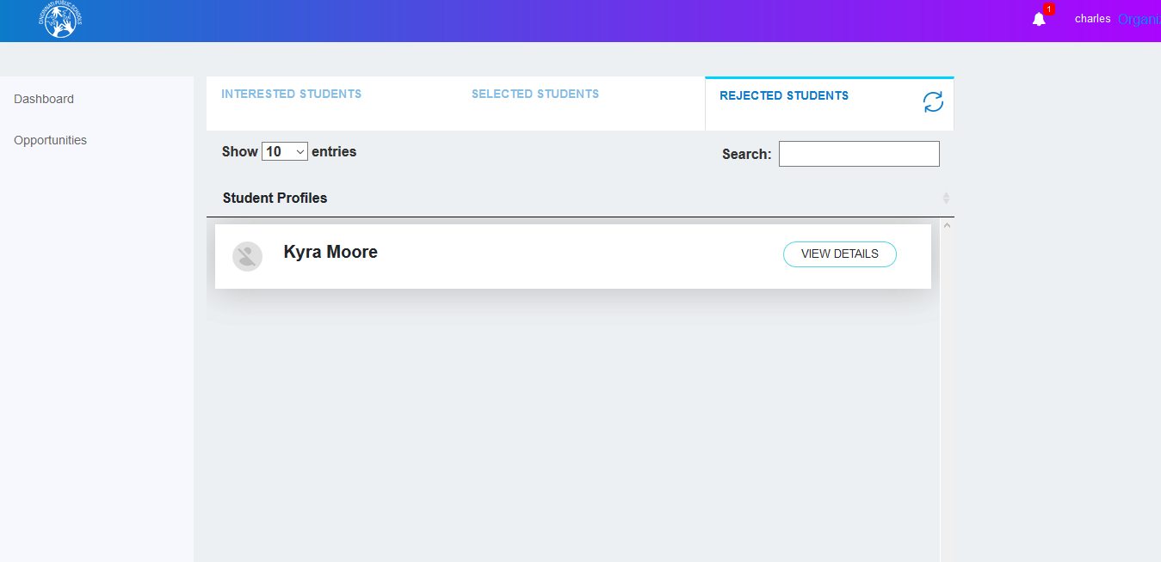

#### To view students’ details:

* On the **Rejected Students,** tab, select the student to view.
* Click the **View Details** button at the bottom of the student.
* Details will show as follows.

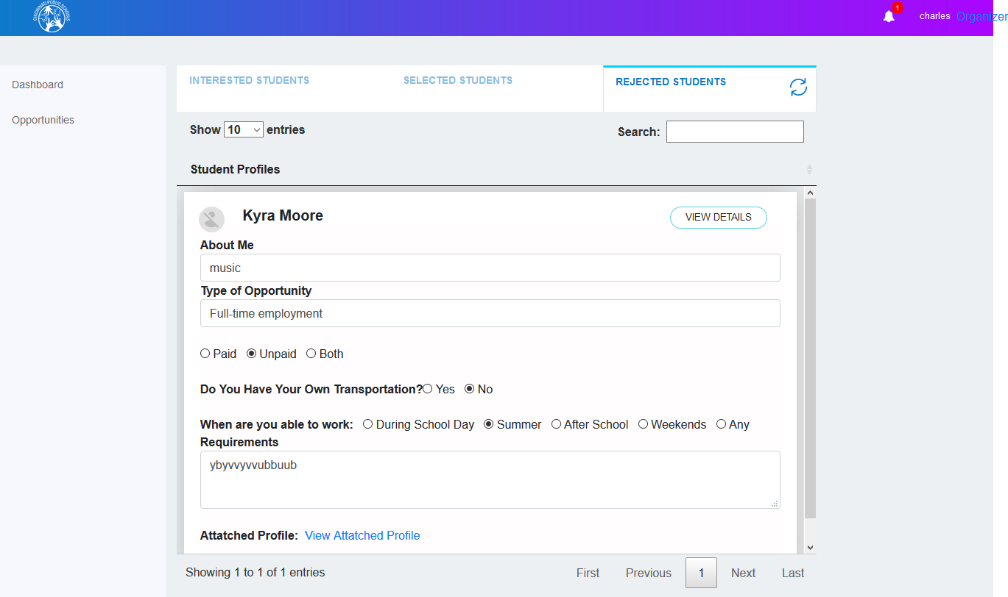

### Rejected Opportunities tab:

In the **Rejected Opportunities** tab, the organizer can view opportunities which are rejected by the administrator. On this screen, you can delete opportunities listed. You can also search for opportunities to delete them.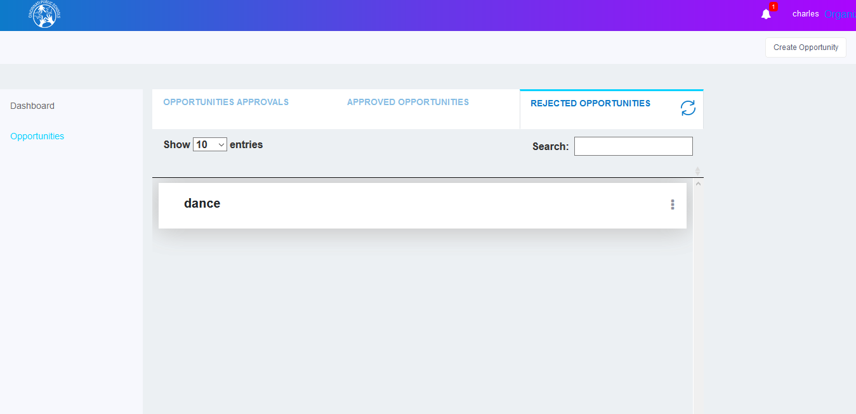

## *To delete opportunity:*

* Click the ellipsis icon as shown in the following screen .
* Click the **Delete Opportunity** button.

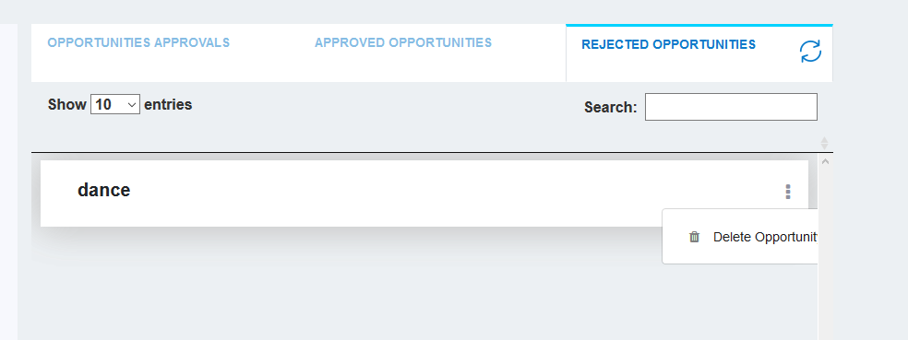

# 3. School Admin

## Logging in:

To log in to the Cincinnati Public Schools website as a school Admin, perform the following steps:

* When click on **Login in with Google** button, it redirects to the Gmail login screen.
* When enter valid Email and Password which is linked with your CPS account, you will be redirected to the School Admin Dashboard screen.
* If your Gmail account is already in login in your screen, you will be redirected to the School Admin Dashboard screen.



* School Admin can see his / her school posts, events, suggestions, posted by school admin and that by the school students